**MOTHER THERESA INSTITUTE OF ENGINEERING AND TECHNOLOGY**



**(AUTONUMOUS)**

**(Approved by AICTE, New Delhi and Affiliated to JNTUA, Ananthapuramu-515002)**

**(NAAC Accredited with A+ &An ISO 9001:2015 Certified Institute)**

**Melumoi (Post), Palamaner-517408.**

**(Email:** [**mtieat@gmail.com**](mailto:mtieat@gmail.com)**,** [**hodcseds@mtieat.org**](mailto:hodcseds@mtieat.org) **Website:** [**www.mtieat.org**](http://www.mtieat.org/)**)**

***Department of***

***CSE (DATA SCIENCE)***

***Laboratory Manual for B.Tech III Year & II Semester***

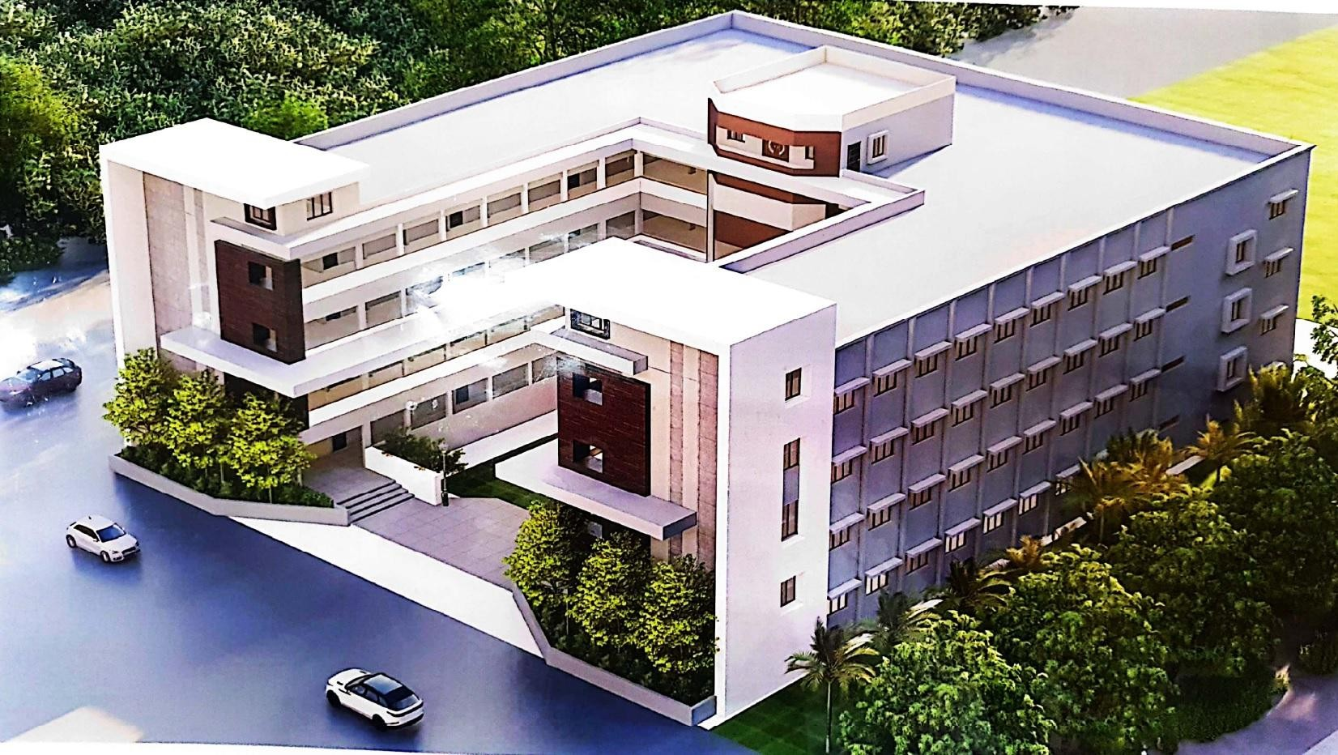

**Course Name :** Cloud Computing Lab

**Course Code :** 20A12604

***(R20 REGULATION)***



***Department of CSE (Data Science)***

***LABORATORY MANUAL***

***For***

B.Tech III Year II Semester (R20 Regulation)

**Course Name :** Cloud Computing Lab

**Course Code :** 20A12604 **Academic Year :** 2023-24 **Batch :** 2021-25

**PREPARED BY: VERIFIED BY:**

SHIVA KUMAR E, Asst. Prof., Dept. of CSE (DS) A. REDDY PRASAD, Assoc. Prof.,

Dept. of CSE (DS)

**PREFACE**

### Department Vision:

To promote quality education with industry collaboration and to enable students with intellectual skills to succeed in globally competitive environment.

### Department Mission:

* To educate the students with strong fundamentals in the areas of Artificial Intelligence and Data Science.
* Provide multi-disciplinary research and innovation driven academic environment to meet the global demands.
* Foster the spirit of lifelong learning in students through practical and social exposure beyond the classroom.

### Programme Educational Objectives (PEO):

Program Educational Objectives describe the career and professional accomplishments in five years after graduation that the program is preparing graduates to achieve.

1. Graduates will have solid basics in Mathematics, Programming, Machine Learning, Artificial Intelligence and Data Science Fundamentals and Advancements to solve technical problems.
2. Graduates will have the capability to apply their acquired knowledge and skills to solve the issues in real world Artificial Intelligence and Data Science sectors and to develop feasible and viable systems.
3. Graduates will have the potential to participate in life-long learning through professional developments for societal needs with ethical values.

### Programme Outcomes (POs):

Program Outcome describes the knowledge, skills and attitudes the students should have at the end of a four year engineering program.

Engineering Graduates will be able to:

1. Engineering Knowledge: Apply the knowledge of mathematics, science, engineering fundamentals and an engineering specialization to the solution of complex engineering problems.
2. Problem Analysis: Identify, formulate, review research literature, and analyze complex engineering problems reaching substantiated conclusions using first principles of mathematics, natural sciences, and engineering sciences.
3. Design / Development of solutions: Design solutions for complex engineering problems and design system components or processes that meet the specified needs with appropriate consideration for the public health and safety, and the cultural, societal, and environmental considerations.
4. Conduct investigations of complex problems: Use research-based knowledge and research methods, including design of experiments, analysis and interpretation of data, and synthesis of the information to provide valid conclusions.
5. Modern tool usage: Create, select, and apply appropriate techniques, resources, and modern engineering and IT tools including prediction and modeling of complex engineering activities with an understanding of the limitations.
6. The engineer and society: Apply reasoning informed by the contextual knowledge to assess societal, health, safety, legal and cultural issues and the consequent responsibilities relevant to the professional engineering practice.
7. Environment and Sustainability: Understand the impact of the professional engineering solutions to societal and environmental contexts, and demonstrate the knowledge of, and need for sustainable development.
8. Ethics: Apply ethical principles and commit to professional ethics and responsibilities and norms of the engineering practice.
9. Individual and team work: Function effectively as an individual and as a member or leader in diverse teams, and in multidisciplinary settings.
10. Communication: Communicate effectively on complex engineering activities with the engineering community and with society at large, such as, being able to comprehend and write effective reports and design documentation, make effective presentations, and give and receive clear instructions.
11. Project management and finance: Demonstrate knowledge and understanding of the engineering management principles and apply these to one’s own work, as a member and leader in a team, to manage projects and in multidisciplinary environments.
12. Lifelong learning: Recognize the need for and have the preparation and ability to engage in independent and lifelong learning in the broadest context of technological change.

### Programme Specific Outcomes (PSOs):

Program Specific Outcomes are statements that describe what the graduates of a specific engineering program should be able to do.

1. Ability to implement innovative, cost effective, energy efficient and eco-friendly integrated solutions for existing and new applications using Internet of Things.
2. Graduates will possess the additional skills in network security and IT infrastructure in Cyberspace.
3. Develop, test and maintain software system for business and other applications that meet the automation needs of the society and industry.

**COURSE OBJECTIVES AND OUTCOMES**

### Course Objectives:

* + Demonstrate application development using Cloud
  + Explain features of Hadoop

### Course Outcomes:

On completion of this course, the students will be able to:

**CO1:** Configure various virtualization tools such as Virtual Box, VMware workstation

**CO2:** Design and deploy a web application in a PaaS environment.

**CO3:** Learn how to simulate a cloud environment to implement new schedulers. **CO4:** Install and use a generic cloud environment that can be used as a private cloud. **CO5:** Manipulate large data sets in a parallel environment

|  |  |  |  |  |  |  |  |  |  |  |  |  |  |  |  |
| --- | --- | --- | --- | --- | --- | --- | --- | --- | --- | --- | --- | --- | --- | --- | --- |
| **Mapping of COs with POs and PSOs** | | | | | | | | | | | | | | | |
| **CO** | **PO1** | **PO2** | **PO3** | **PO4** | **PO5** | **PO6** | **PO7** | **PO8** | **PO9** | **PO10** | **PO11** | **PO12** | **PSO1** | **PSO2** | **PSO3** |
| **CO1** | 3 | 3 | 2 | 2 | 3 | 2 | 2 | 0 | 1 | 2 | 1 | 2 | 3 | 3 | 3 |
| **CO2** | 3 | 3 | 3 | 3 | 3 | 1 | 1 | 0 | 1 | 1 | 1 | 1 | 3 | 2 | 2 |
| **CO3** | 3 | 3 | 3 | 3 | 2 | 2 | 1 | 0 | 2 | 1 | 1 | 1 | 3 | 3 | 2 |
| **CO4** | 2 | 2 | 2 | 2 | 3 | 1 | 1 | 0 | 1 | 1 | 1 | 2 | 3 | 2 | 2 |
| **CO5** | 3 | 2 | 3 | 3 | 3 | 2 | 2 | 0 | 1 | 2 | 2 | 1 | 3 | 2 | 1 |
| **TOT** | 3 | 3 | 2 | 2 | 3 | 2 | 2 | 0 | 1 | 2 | 1 | 2 | 3 | 3 | 3 |

### Install VirtualBox/VMware Workstation with different flavours of Linux or windows OS on top of windows operating systems.

**Aim:** To install VirtualBox/VMware Workstation with different flavours of Linux or windows OS on top of windows operating systems.

### Procedure:

Exp1: Install Virtualbox

Step1: Download Virtualbox(Go to browser and search for suitable Virtual Box. Here we installed version 5.2.44)

Step-2: Click on Window host and install the downloaded file.

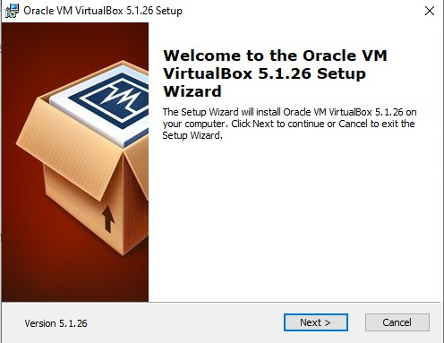

Step-3: Give Next and finally give Install

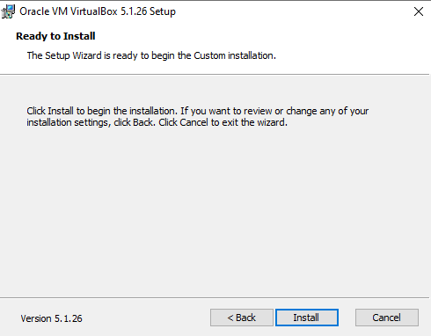

Step-3: Click on Finish

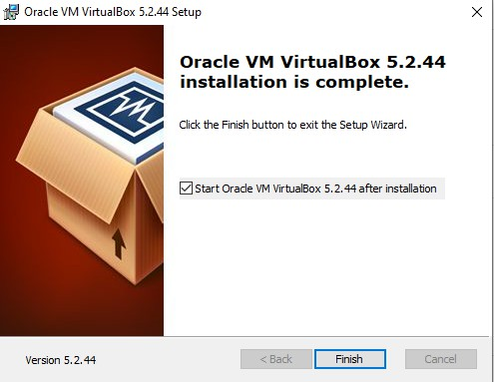

Step-4: Now go to Virtual Box

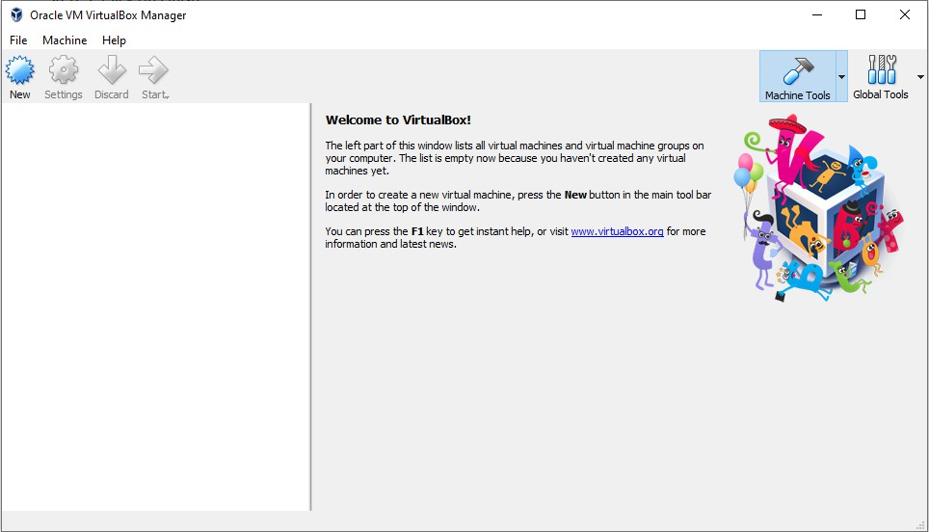

Step-5: Go to browser and search for <https://old-releases.ubuntu.com/releases/16.04.3/> and download the ubuntu file and Open

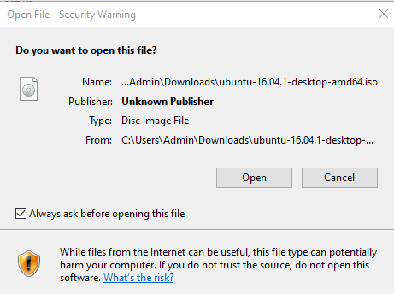

Step-6: Now go to Virtualbox and Click New and give name as Ubuntu and set Type:Linux and Version:64 and Click on Next

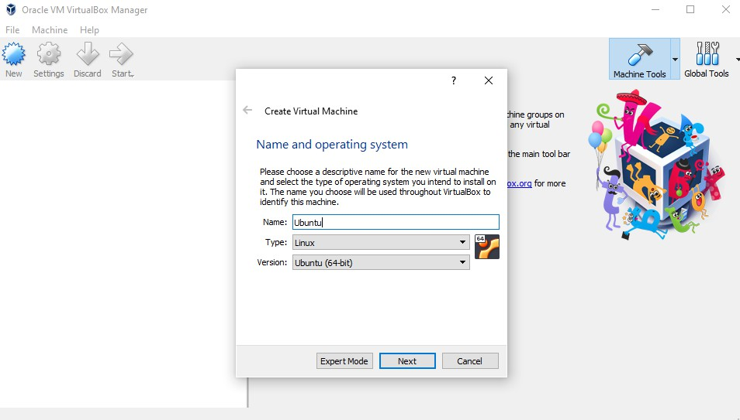

Step-7: Click Next for all options and finally Create Ubuntu

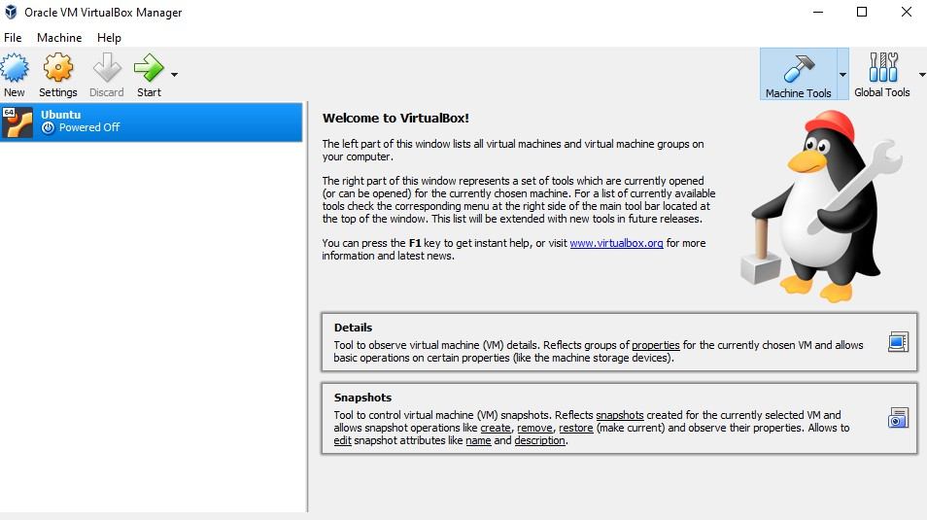

Step-8: Go to settings and choose the following disk path

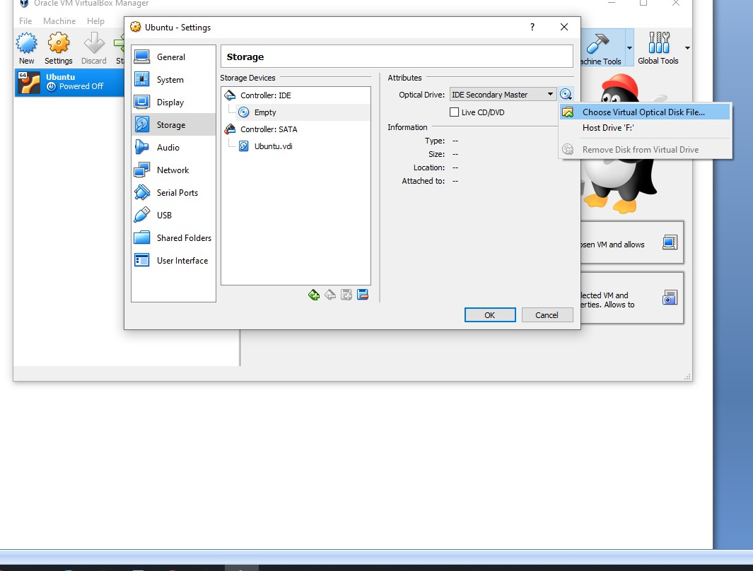

Step-9: Select the Ubuntu downloaded file and click OK

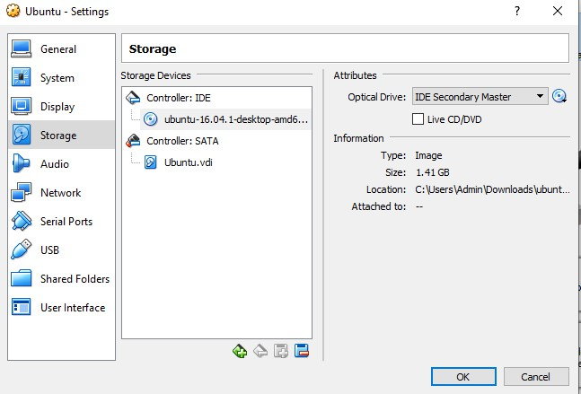

Step-10: Now click on Start, so that ubuntu will get installed.

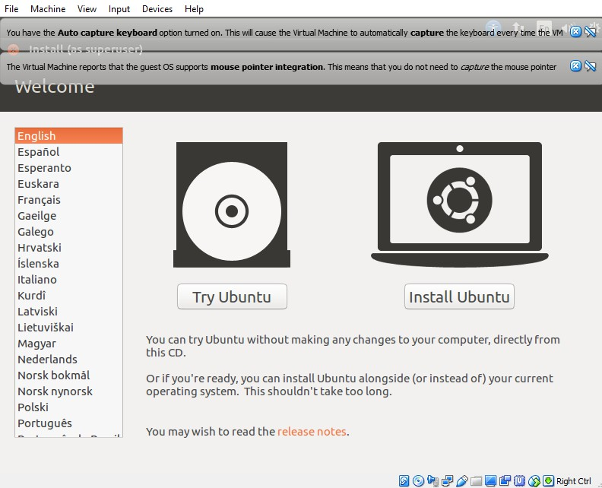

Step-11: Now select Language(English) and Install Ubuntu

Step-12: Click on continue(Because already Ubuntu is downloaded)

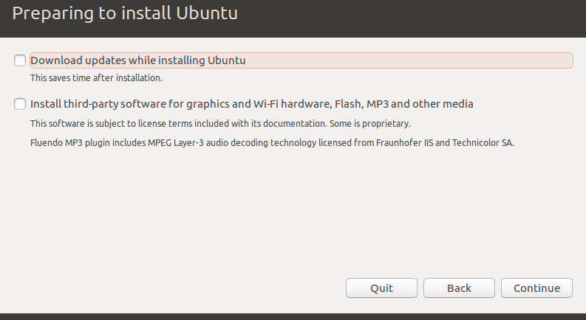

Step-13: Click on Install

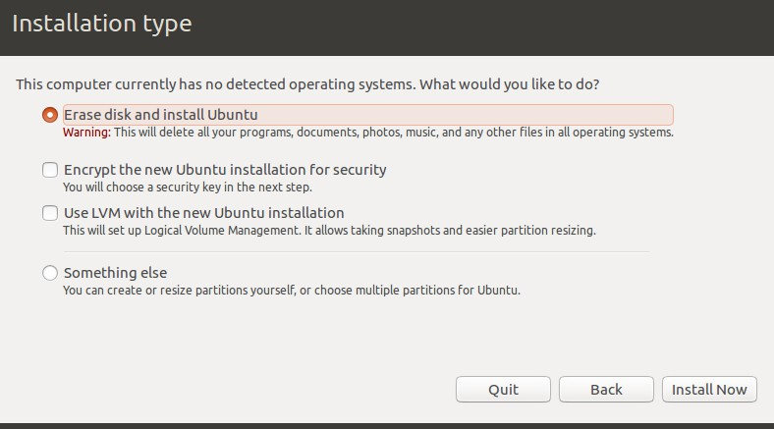

Step-14: Click Continue

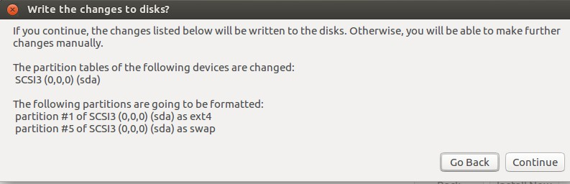

Step-15: Click Continue(If the default location is not wrong)

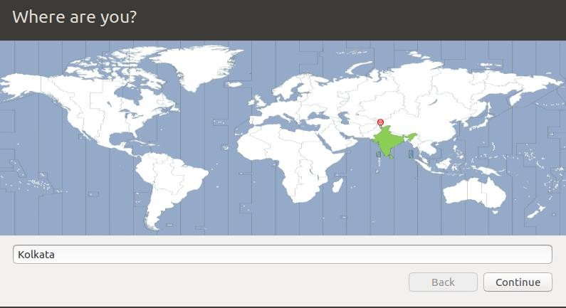

Step-16: Click Continue

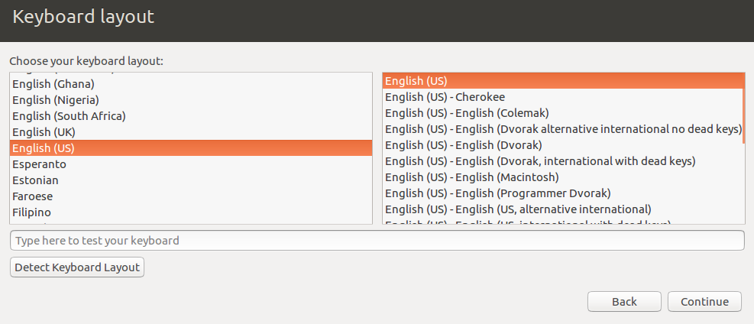

Step-17: Fill the form and click on Continue

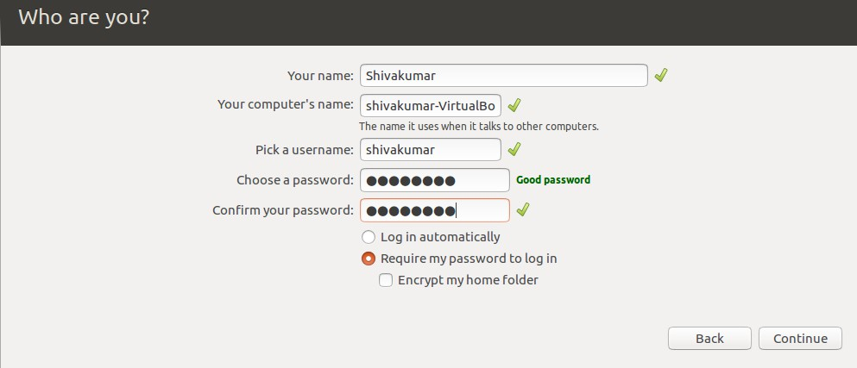

Step-18: Wait until the ubuntu is installed

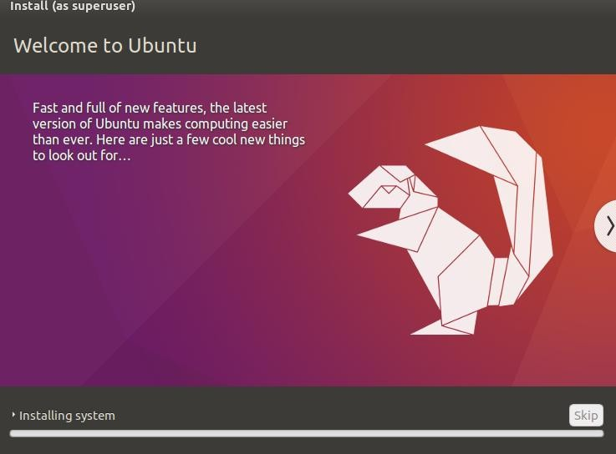

Step-19: Once if everything is loaded, finally it asks to restart the computer, Click on Restart

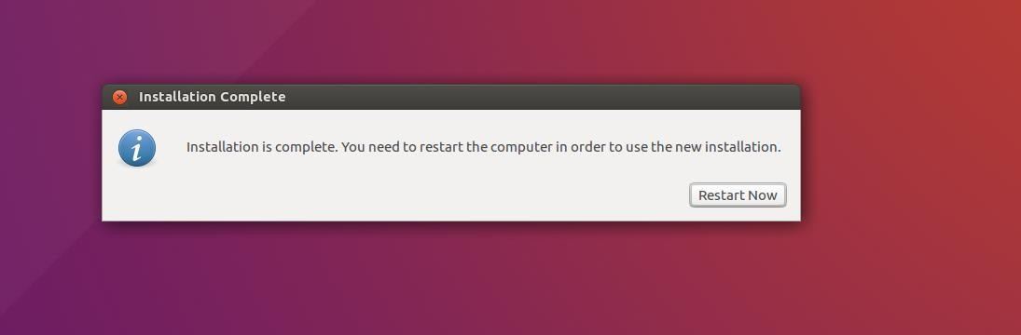

Step-20: So, finally Ubuntu OS is installed successfully.

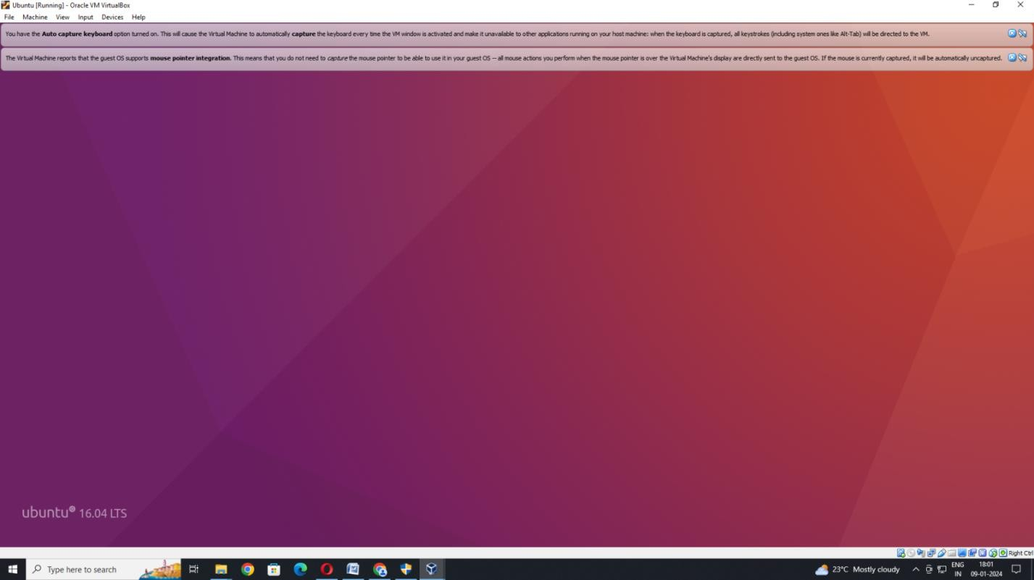

**Result:** Thus, VMware Workstation with different flavours of linux or windows OS on top of windows7 or 8 or 10.has been successfully installed and executed.

### Install a C compiler in the virtual machine created using virtual box and execute Simple Programs

**Aim:** To install a C compiler in the virtual machine created using virtual box and execute Simple Programs.

### Procedure:

Step-1: Open Virtual Box which was installed in Experiment No. 1 and click on Start

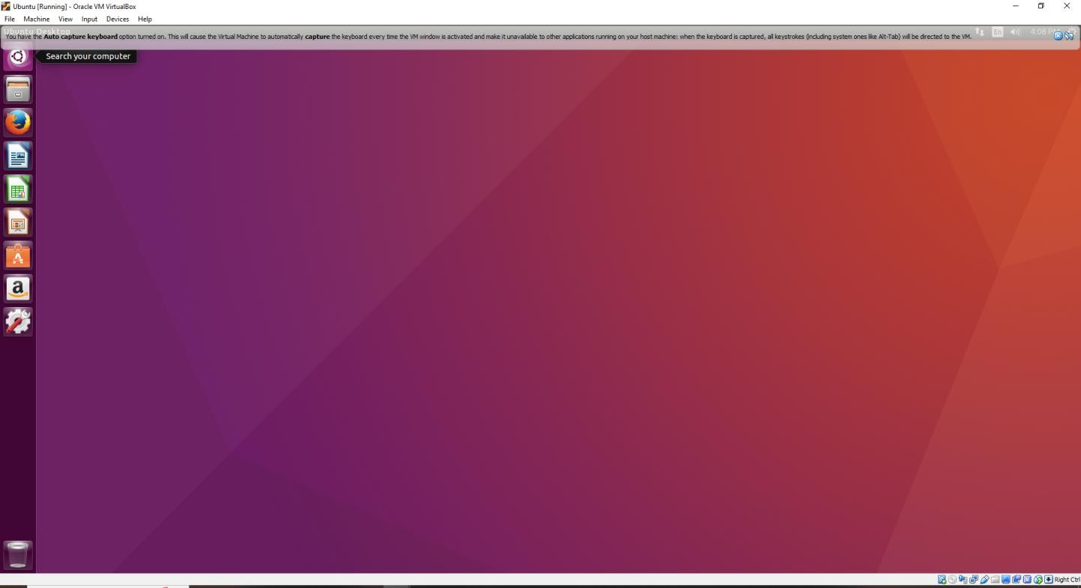

Step-2: Now go to Terminal(Search in Search bar) and click on Terminal

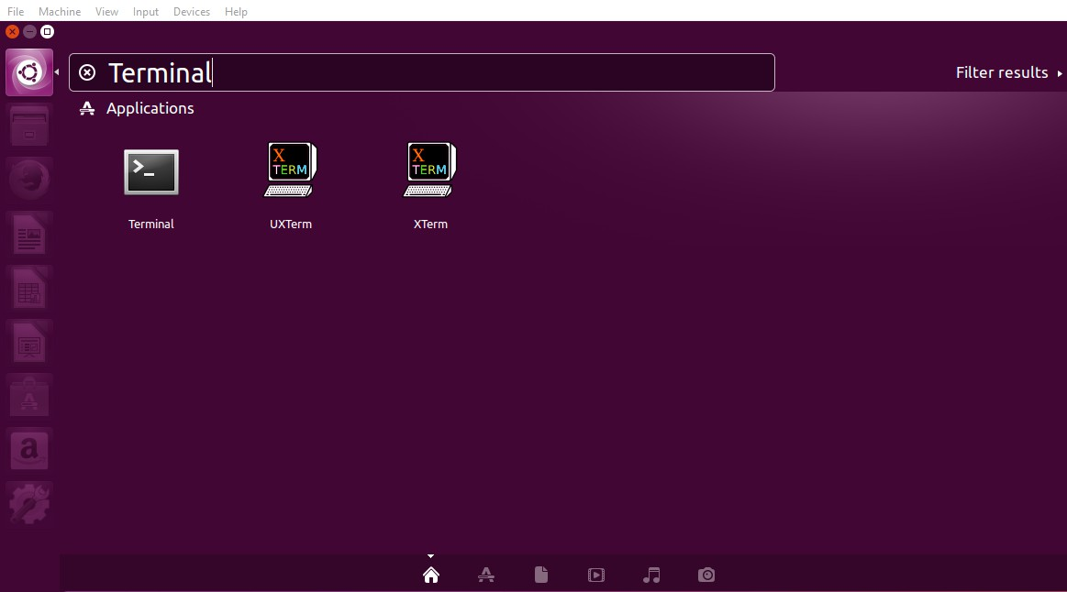

Step-3: Now Terminal is opened.

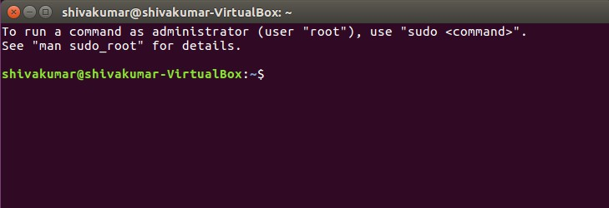

Step-4: Check whether gcc is installed in Ubuntu OS or not by giving the following command

### gcc –version

(If it is not installed then follow the command **sudo apt install build-essential**)

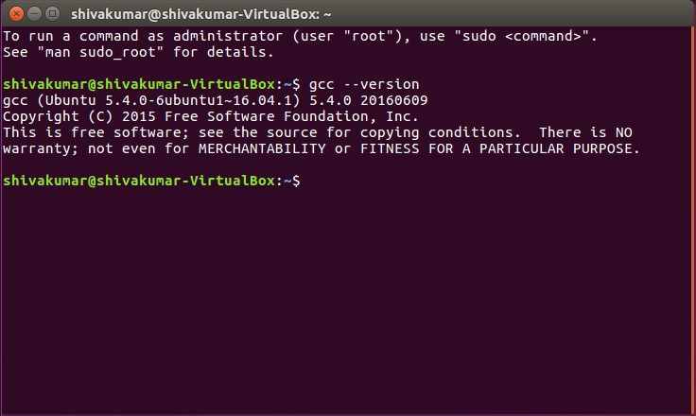

Step-5: Now go to Text editor and type the following C program and save it as Hello.c

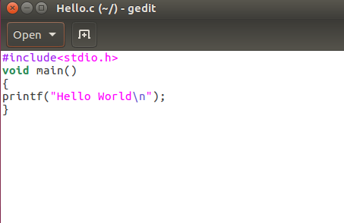

Step-6: Now go to terminal and run the following commands

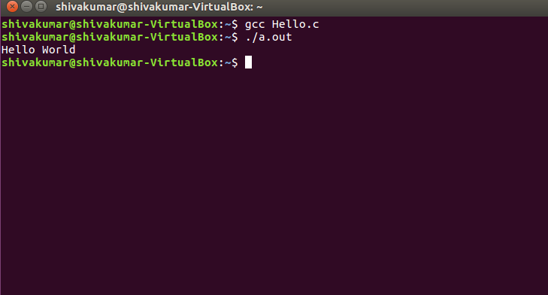

**Result:** Thus a C compiler is installed in the virtual machine and C program was executed and output was obtained successfully.

### Install Google App Engine. Create hello world app and other simple web applications using python/java.

**Aim:** To Install Google App Engine. Create hello world app and other simple web applications using python/java.

### Procedure:

Step 1: Download Python using https:/[/www.python.org/downloads/windows/](http://www.python.org/downloads/windows/)

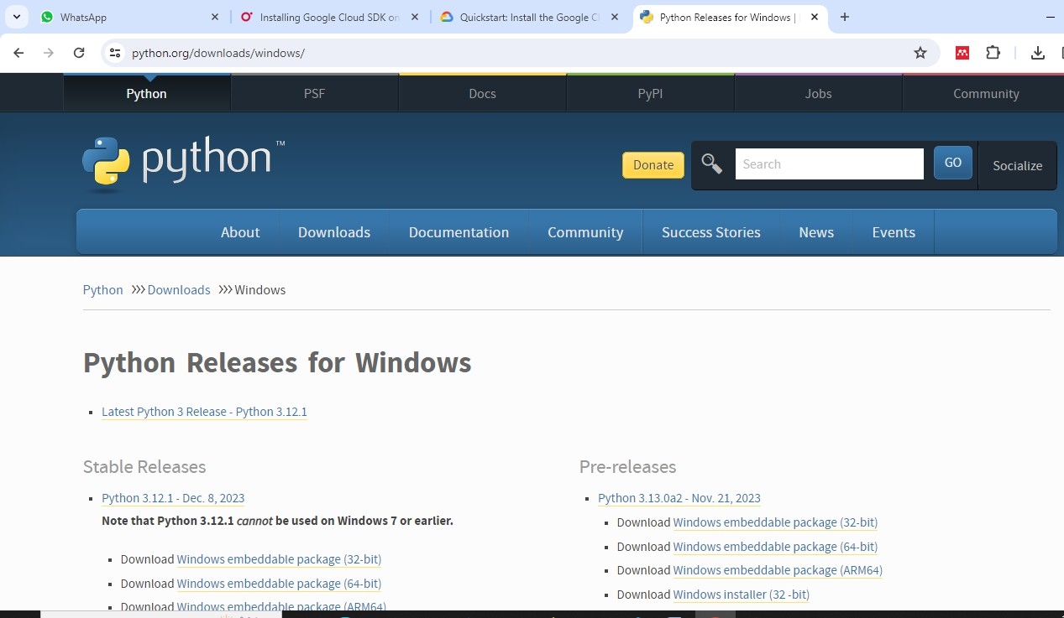

Step-2: click install now

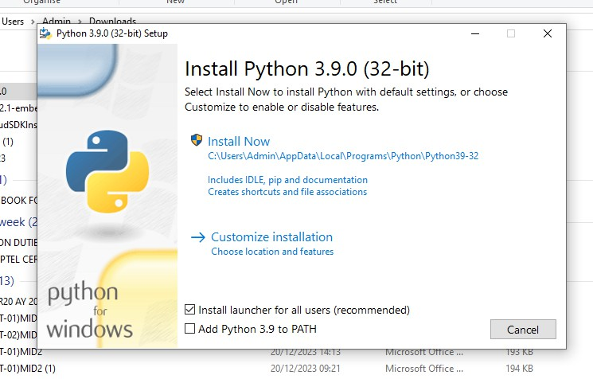

Step-3: Setup will start now

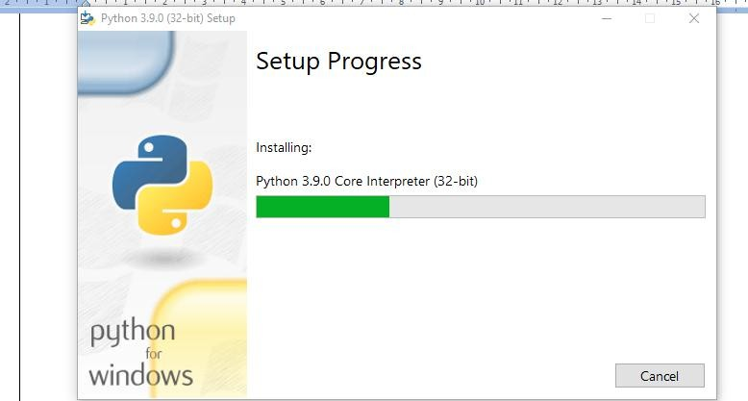

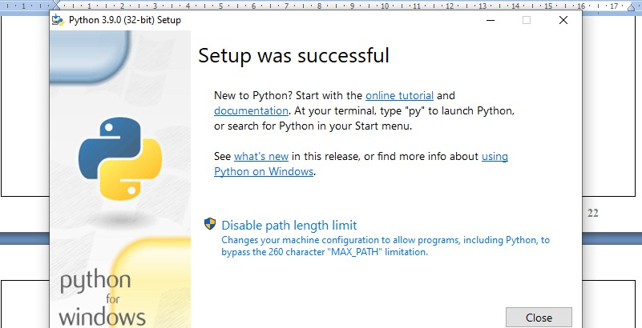Step-4: Setup is successful.

Step-5: Check the working of Python software by executing any simple program.

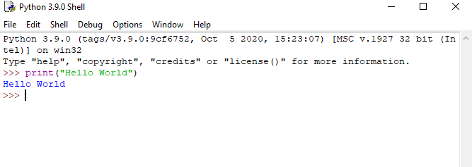

Step-6: Now Install Google cloud sdk using the link <https://cloud.google.com/sdk/docs/install-sdk> And click Google Cloud CLI Installer

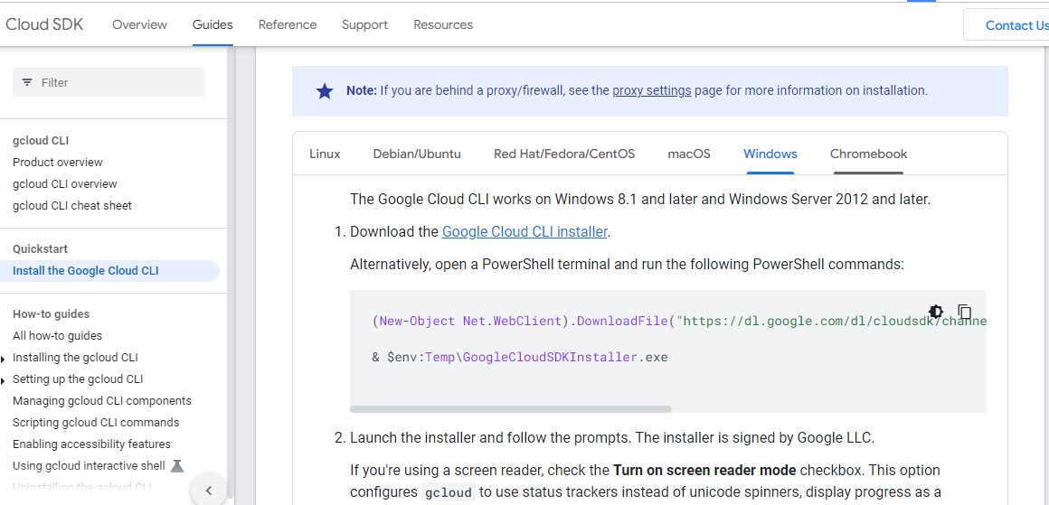

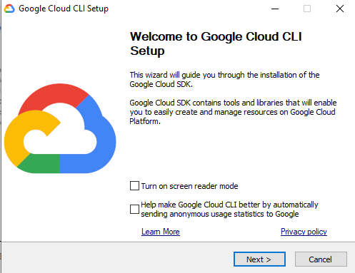Step-7: Click Next

Step-8: Click I Agree

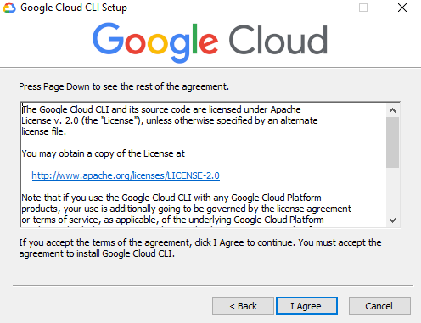

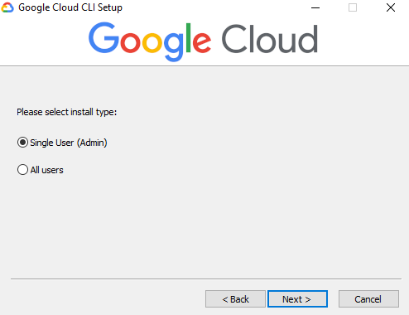Step-9: click Next

Step-10: Click Next

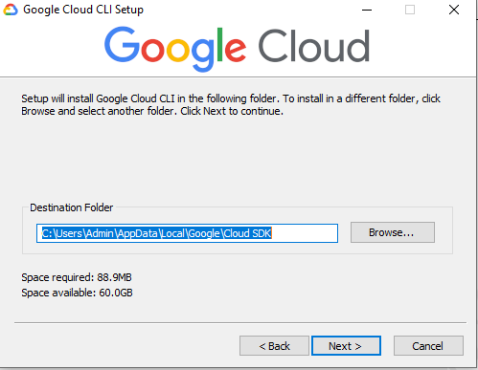

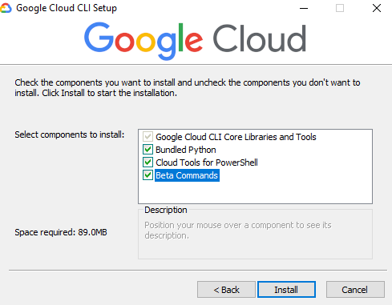Step-11: Give Install

Step-12: Wait until all the files get loaded and then give finish.

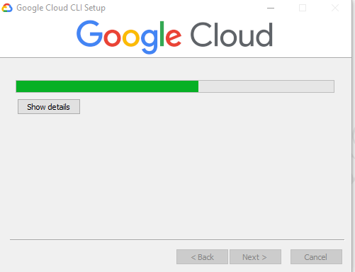

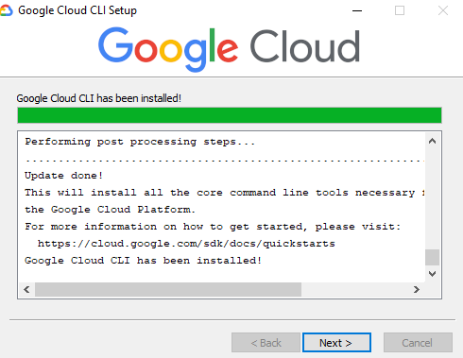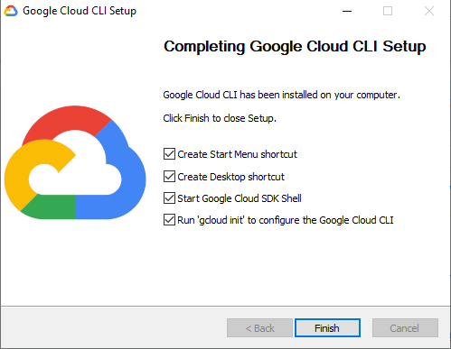Step-13: Give Next and Finsh

Step-14: Then Give y (yes)

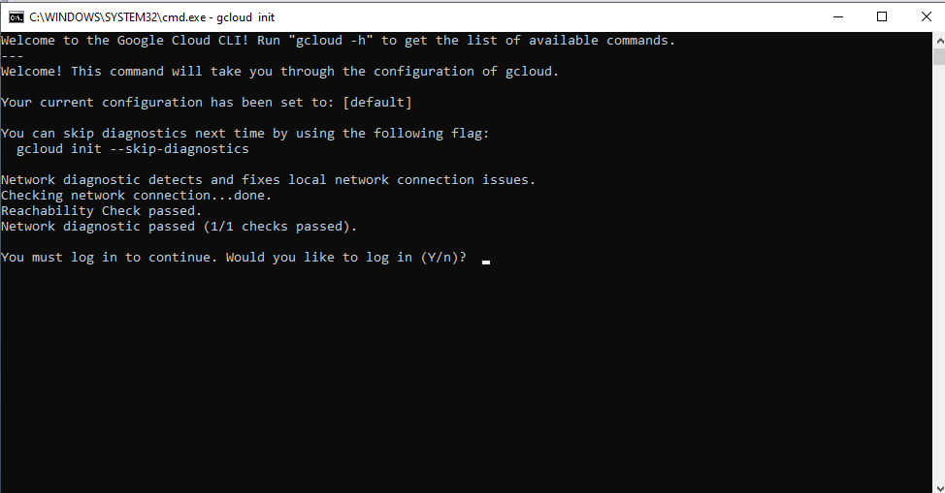

Step-15: Choose your mail id and get registered.

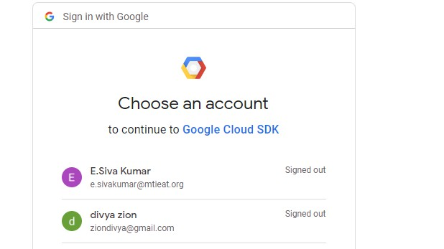

Step-16: Give allow

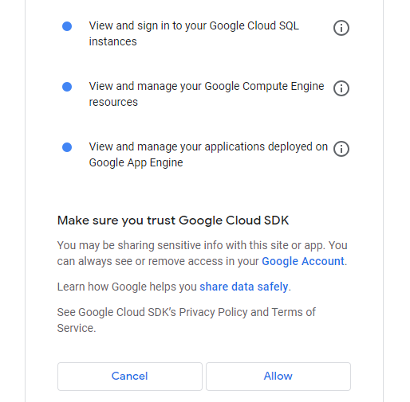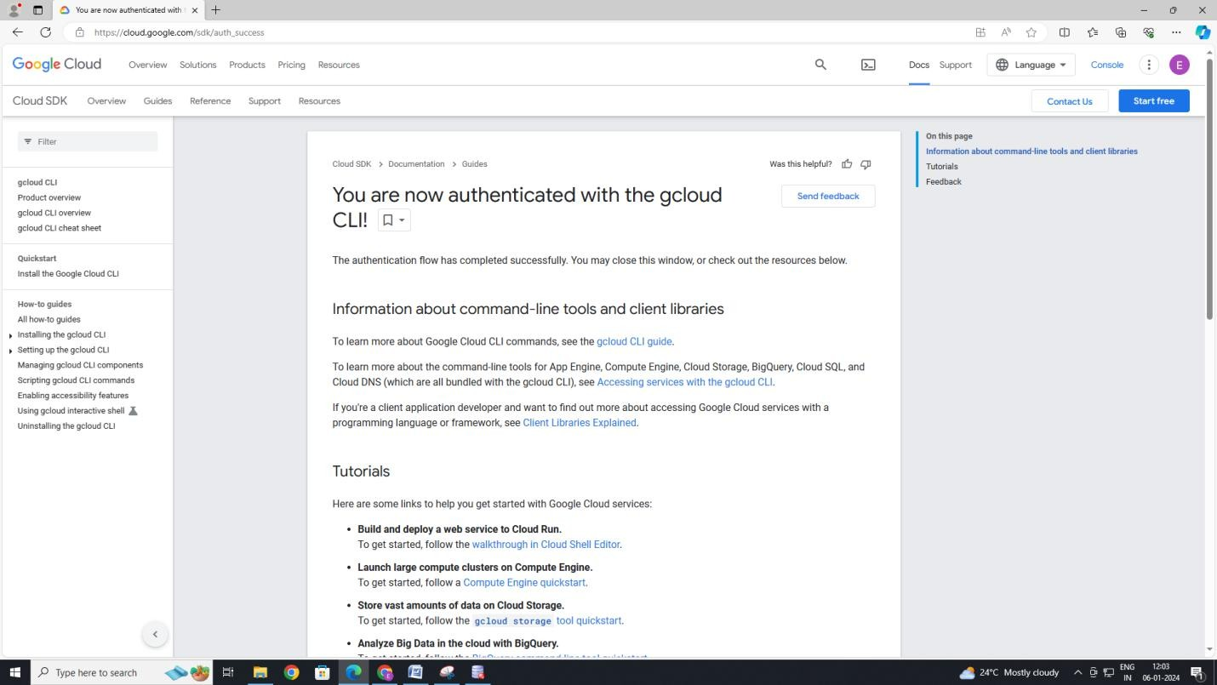

Step-17: Now you are logged in to App Engine

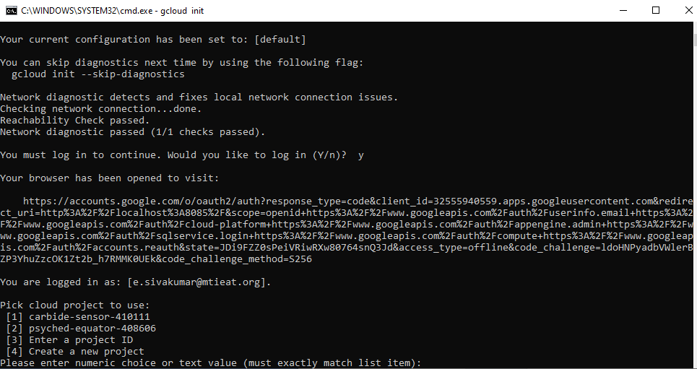

Step-18: Open Python IDLE and write a simple Hello World program and save it with the file name “index.py”

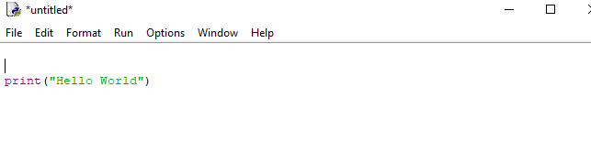

Step-19: Create another text file named “app.YAML” with the given content

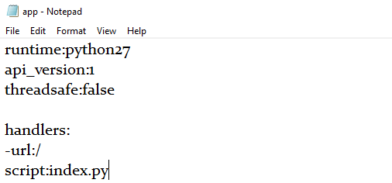

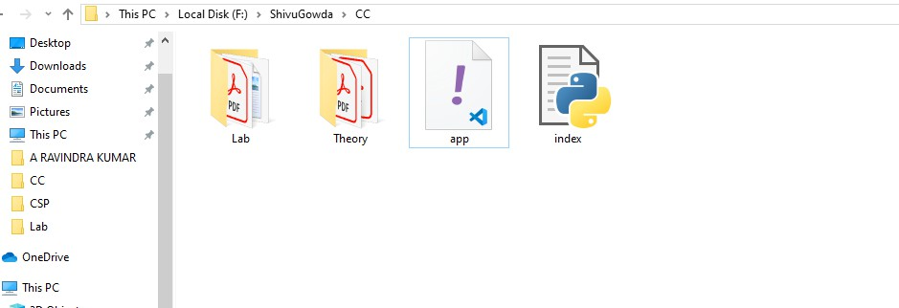Step-20: Make sure both “index.python” and “app.YAML”. file are in same folder

Step-21: Go to cloud SDK and give the following command google-cloud-sdk\bin\devappserver.py “specify the path”

**Result:** Thus google app engine is installed successfully in the system.

1. **Use GAE launcher to launch the web applications Aim:** To Use GAE launcher to launch the web applications.

### Procedure:

Step 1: Download & Install Python2.7 old version

Step 2: Download and Install Google app engine launcher using the given link

Link-→ <https://drive.google.com/file/d/1Uuxc9PTDHZ_l7zOxBnKfn4XbBnd0iLtK/view>

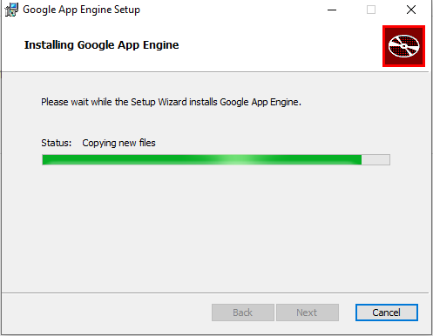

Step-3: click finish after successful installation.

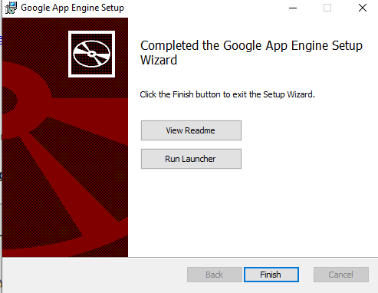

Step-4: Open app engine launcher

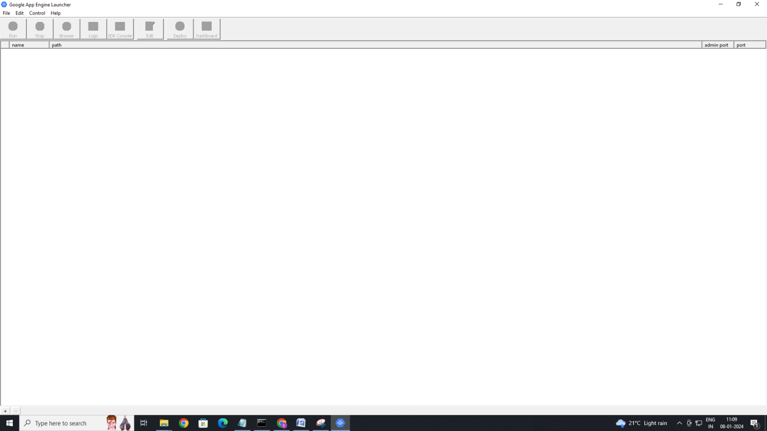

Step-5: Go to edit and choose Preferences

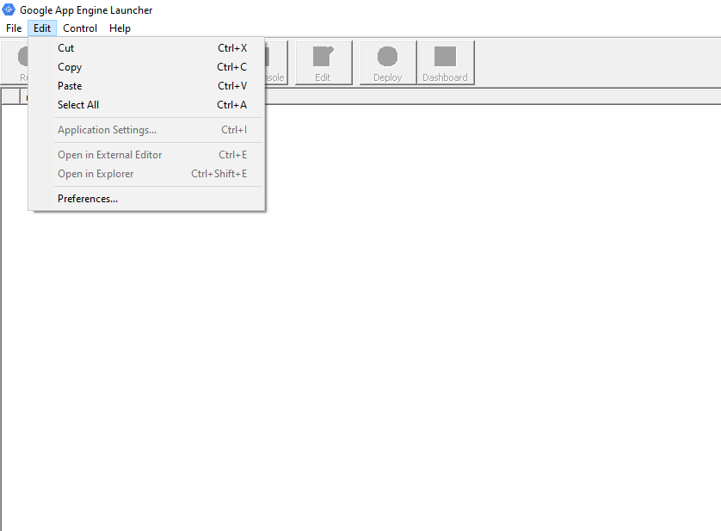

Step-6: Choose both Python and app engine file location as specified and click OK

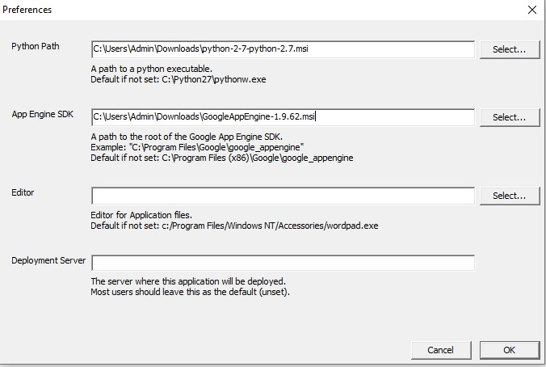

Step-7: Now Go to file and choose create New Application:

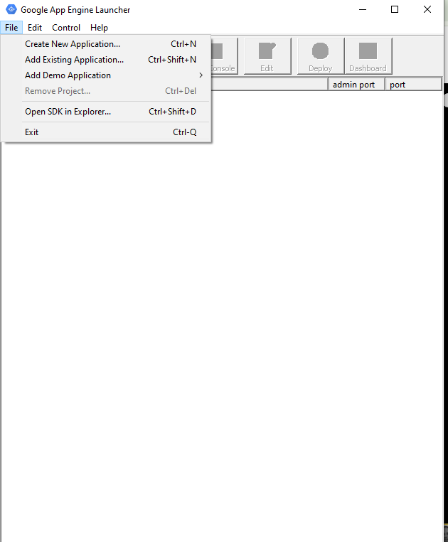

Step-8: Create a new folder on desktop and paste its path as specified at parent Directory and click on create.

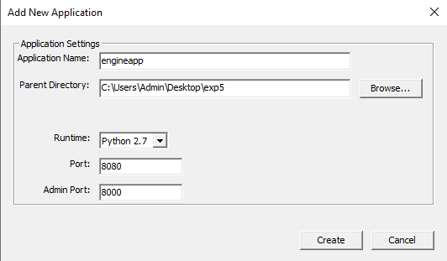

Step-9: Now the path is linked to engineapp and the basic files are available in out desktop folder. Therefore select the path and click on Run

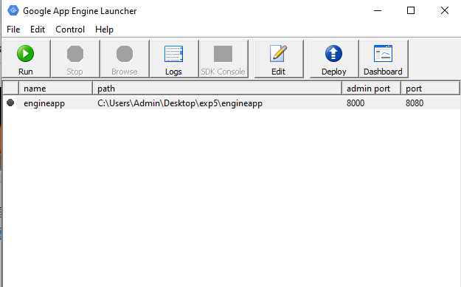

Step-10: Now check the port no(Here it is 8080)

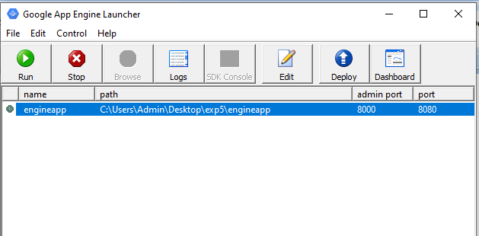

Step-11: Now go to browser and search for localhost:8080(because our port number generated in app engine was 8080) to get the output.

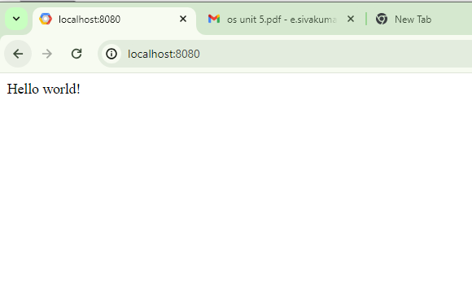

**Result:** Thus, GAE launcher has successfully launched the web applications.

### Simulate a cloud scenario using CloudSim and run a scheduling algorithm that is not present in CloudSim.

**Aim:** To Simulate a cloud scenario using CloudSim

### Procedure:

General steps:

* 1. Java Installation
  2. Download Cloud sim and Commons math jar file
  3. Eclipse IDE Installation
  4. Run cloud sim setup in Eclipse

1. **Java Installation:**
   1. **Check Java in your system**
   2. **If java not installed then download Java**
   3. **Install Java Set up**
   4. **Set path variable for java**

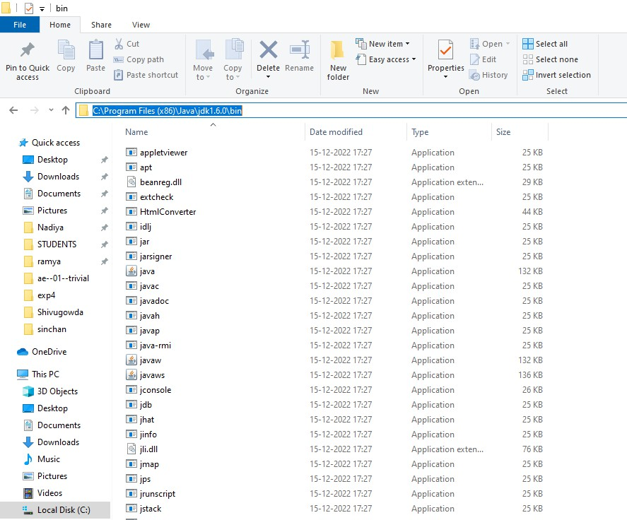Step-1: Copy the path as specified

Step-2: Search for System environment variables

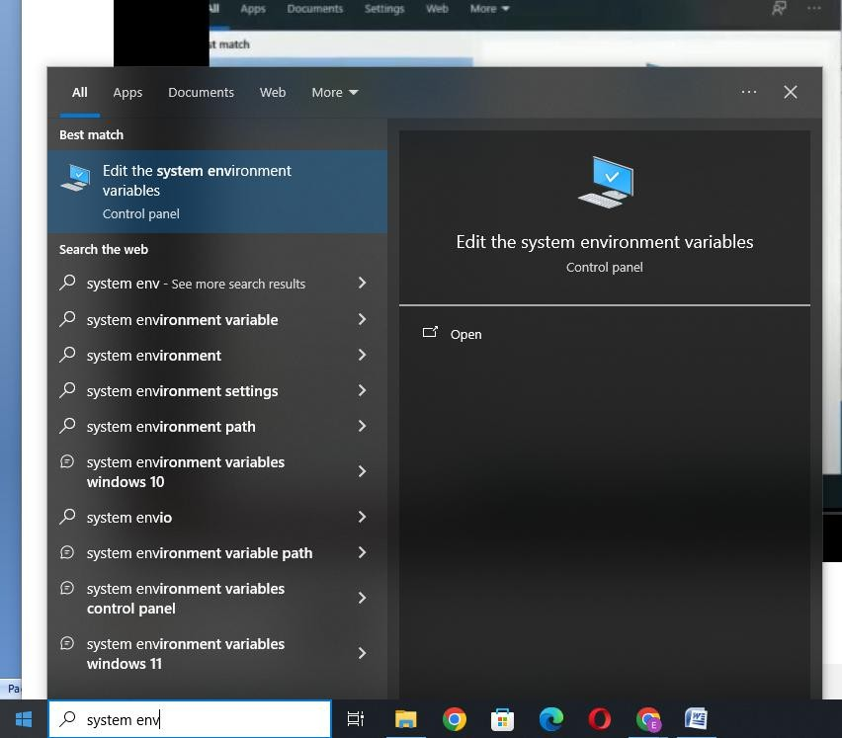

Step-3: Now go to Environment variables

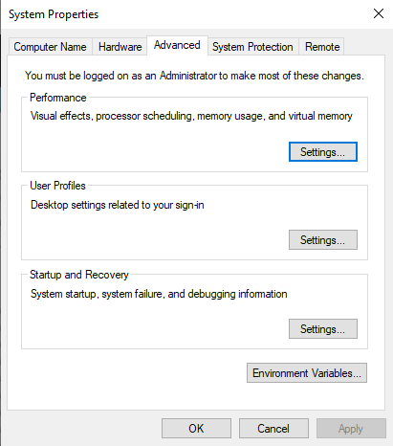

Step-4: Select Path as specified and click on Edit

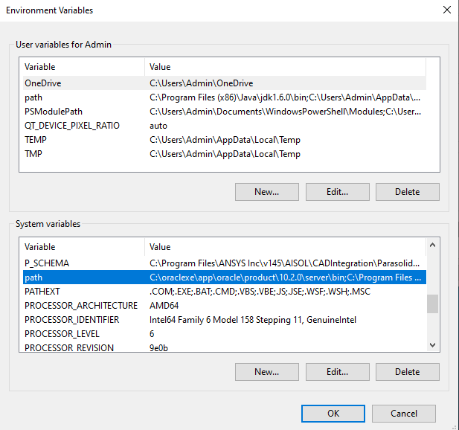

Step-5: Click on New and paste the path which you copied from java bin folder and click OK

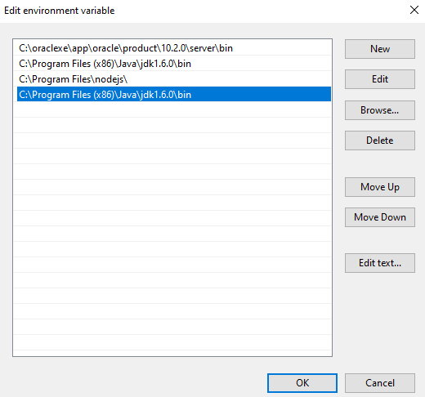

Step-6: By clicking OK close all popup windows.

### Download cloudsim and additional jar files

* 1. **Download Clousim 3.0.3**

Step-1: Go to <https://github.com/Cloudslab/cloudsim/releases/tag/cloudsim-3.0.3> and download the file(Zip file) and extract the files.

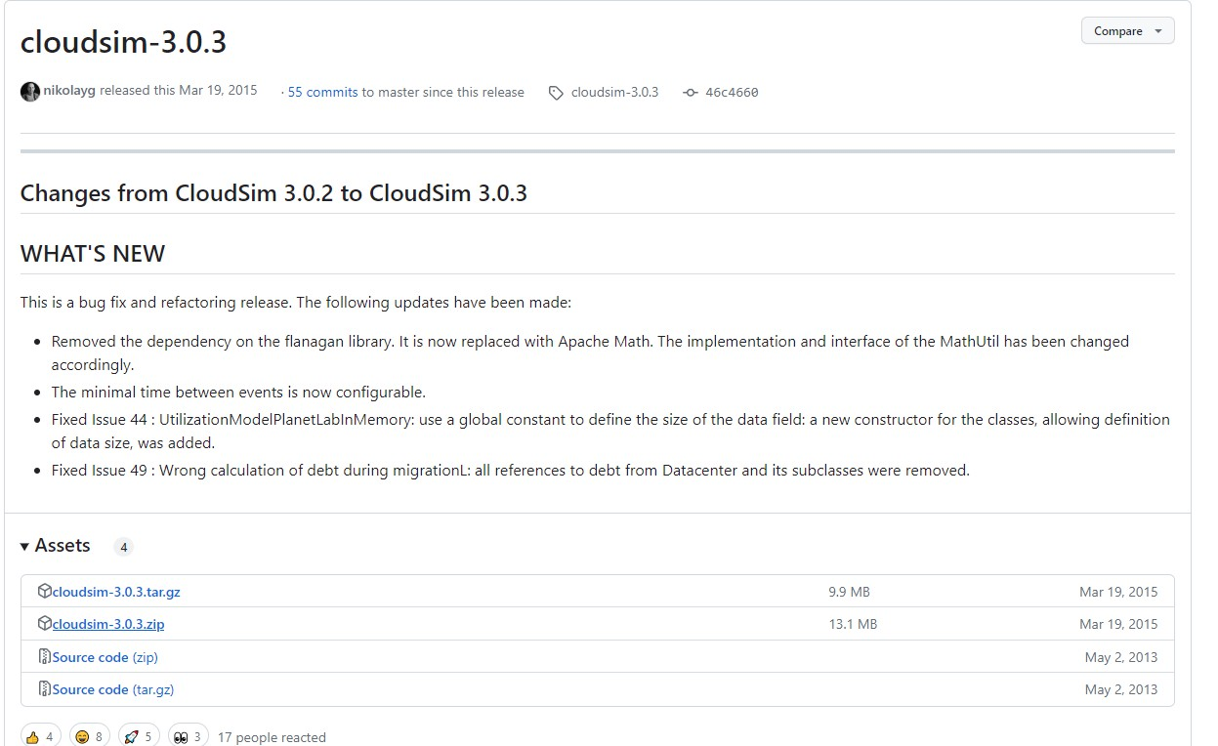

Step-2: After extracting all the files Cloud sim folder will have the following files.

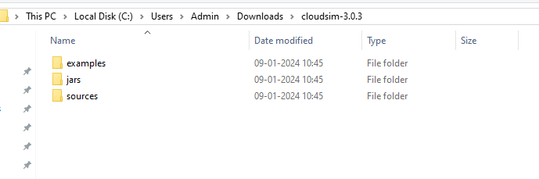

### Download Commons math 3 jar file

Step-1: Go to <https://commons.apache.org/math/download_math.cgi> and download Common math 3 jar file

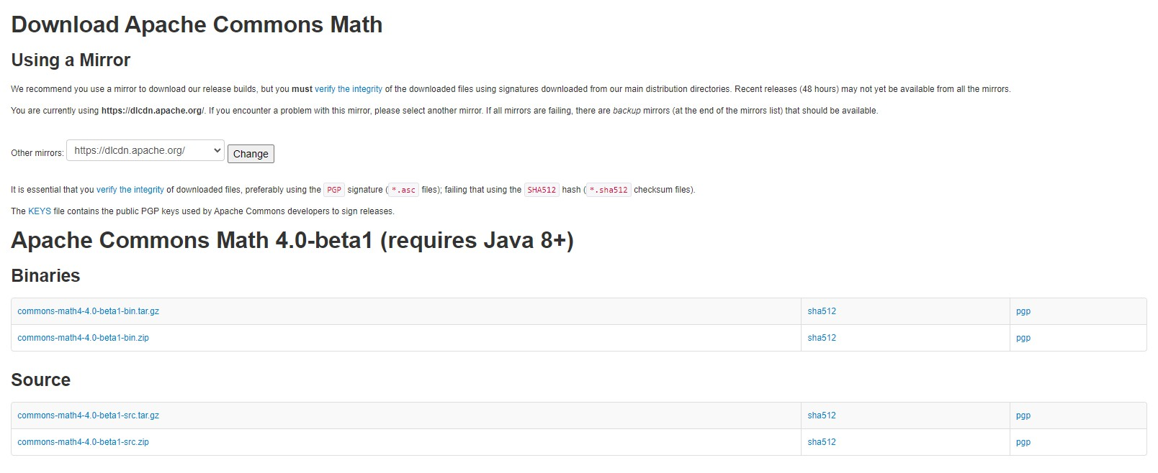

### Eclipse IDE Installation

* 1. **If java 64 is installed then download 64 bit Eclipse otherwise for java 32 bit download Eclipse 32 bit.**

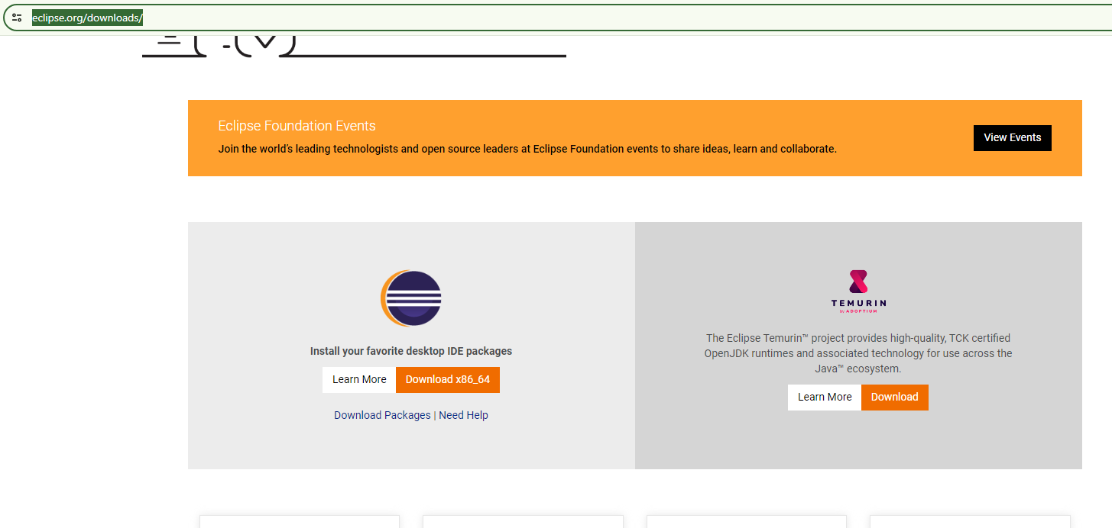Step-1: Go to <https://www.eclipse.org/downloads/> and download Eclipse

### Install Eclipse IDE

Step-1: Install the downloaded Eclipse file by selecting Eclipse IDE for Java Developer

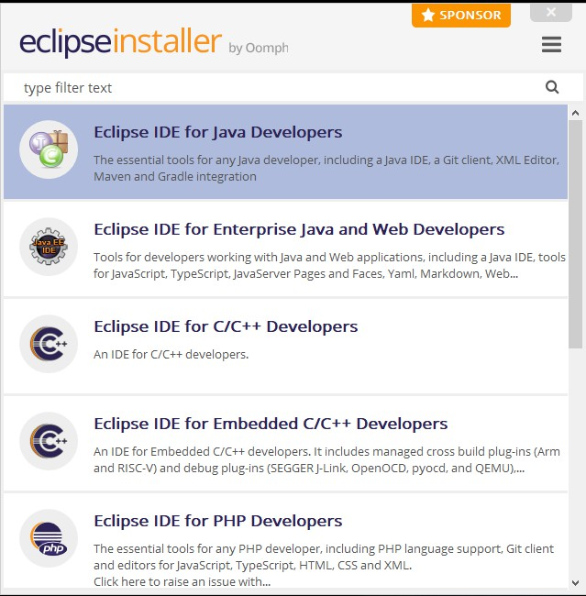

Step-2: Click on Install

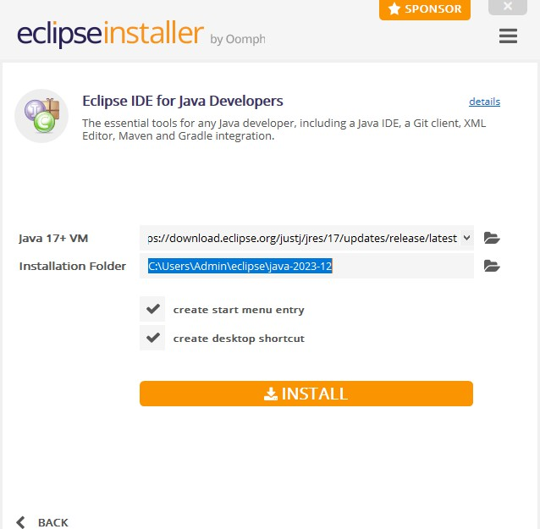

Step-3: Wait until the Eclipse is installed.

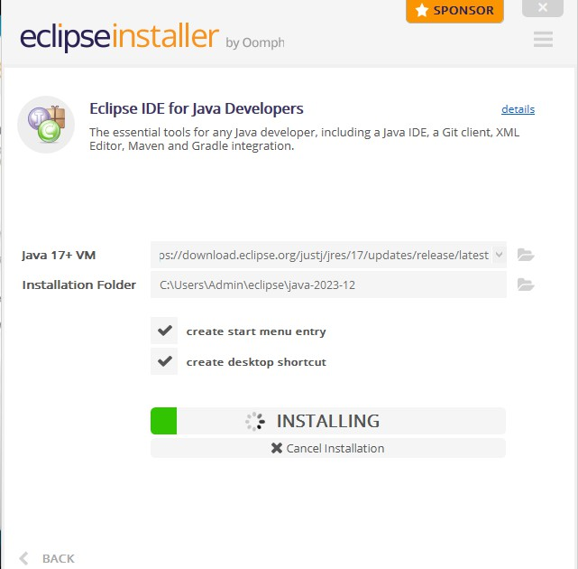

Step-4: Now clock on Launch

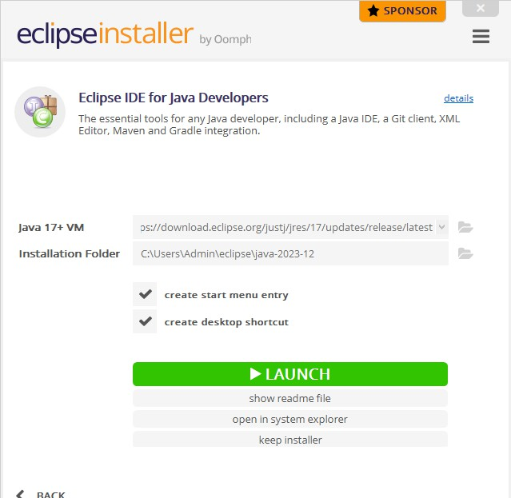

Step-5: Launch the Eclipse on specified default location.(Select Use this as the default and do not ask again).

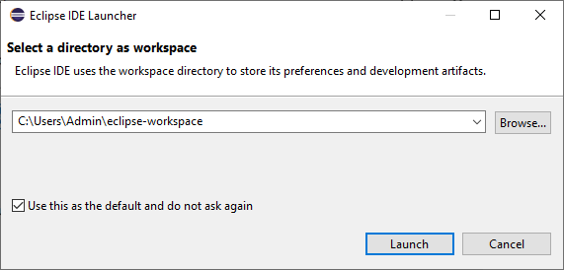

### Run cloud sim setup in Eclipse

* 1. **Put up Commons-math-3-3.6.1.jar file into jar folder of Cloudsim 3.0.3**

Step-1: Go to Commons-math file and copy the jar file as specified.

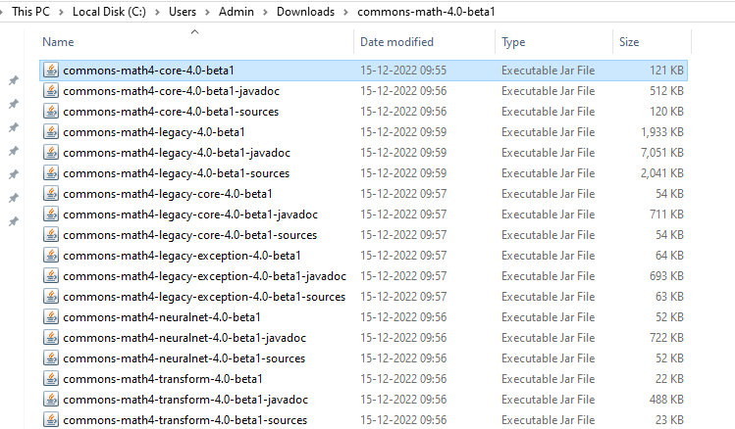

Step-2: paste the jar file in cloud sim as specified.(Check the path carefully and paste it).

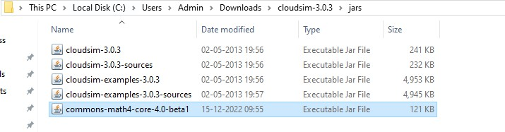

### Build a new java project with cloudsim 3.0.3 folder.

Step-1: Open Eclipse Software and go to File→New-→ Java Project

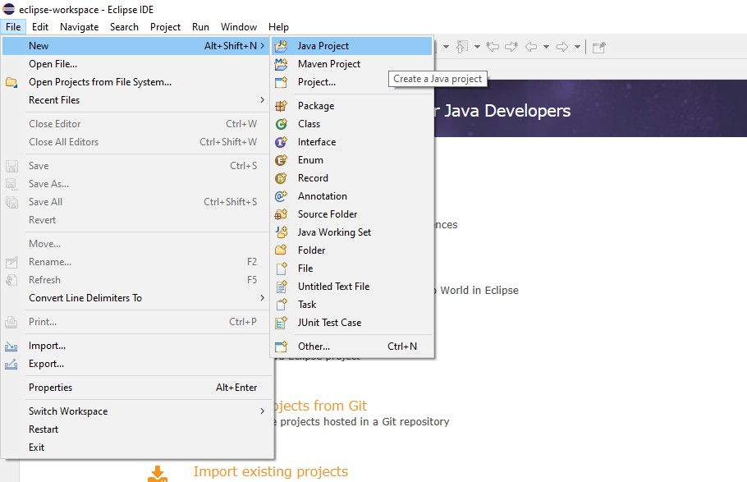

Step-2: Give a name for Project.

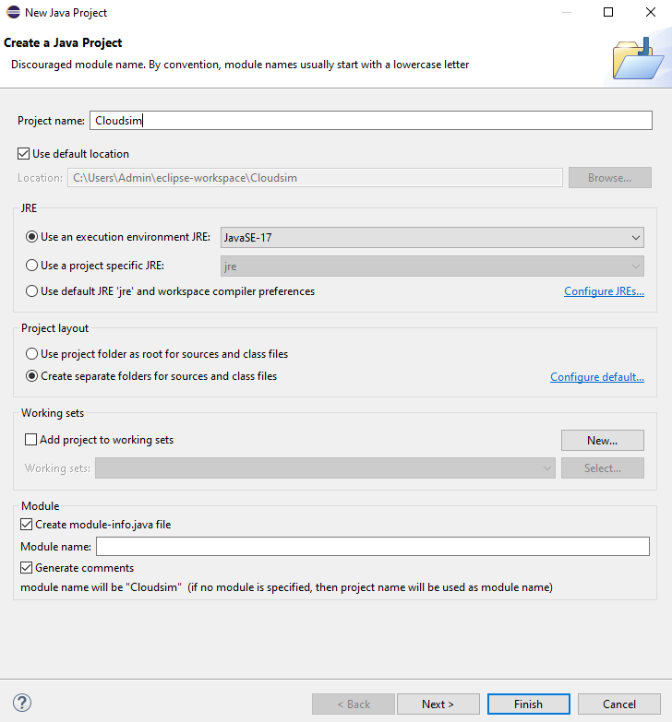

Step-3: Now Choose the default location as Cloudsim folder and click on Next

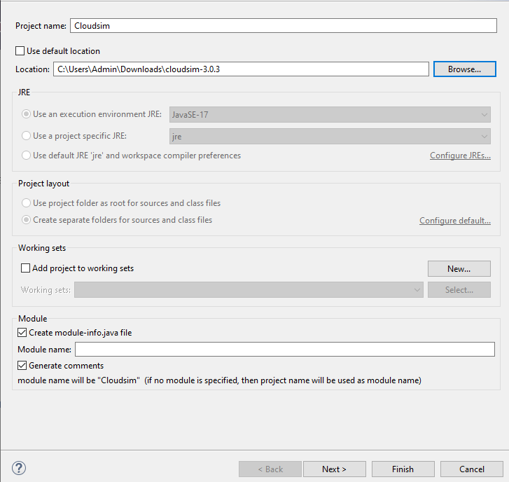

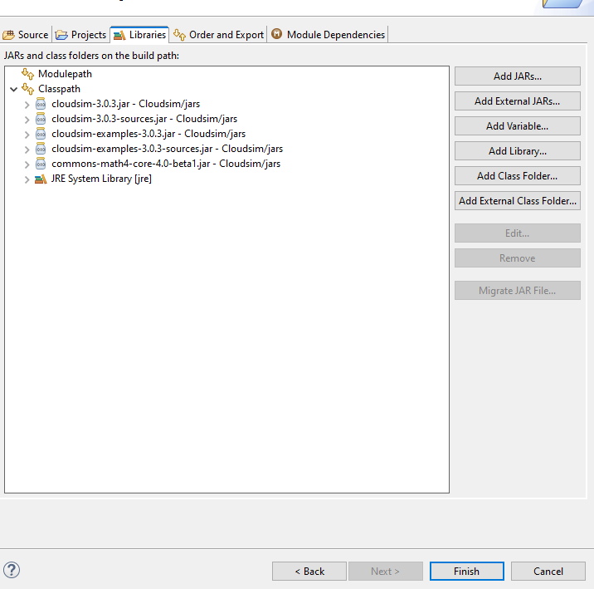Step-4: Here go to Libraries(To check the files) and Give Finish.

Step-5: Now Select any Example Program under Your Project as shown below

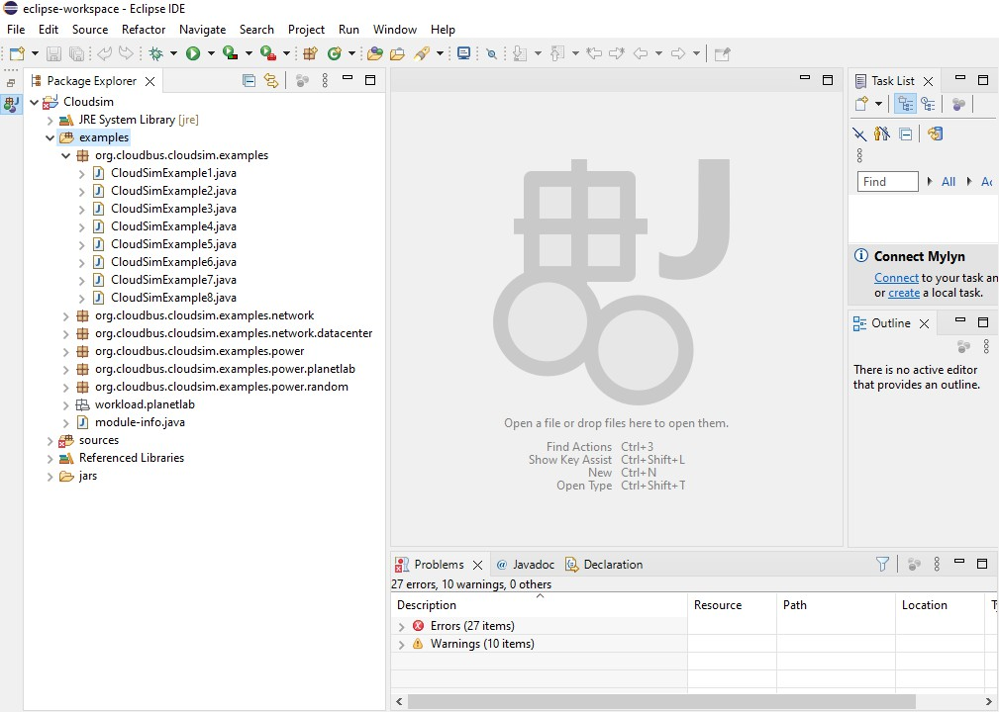

Step-6: Now Open Example1 program and Run the program to check the output

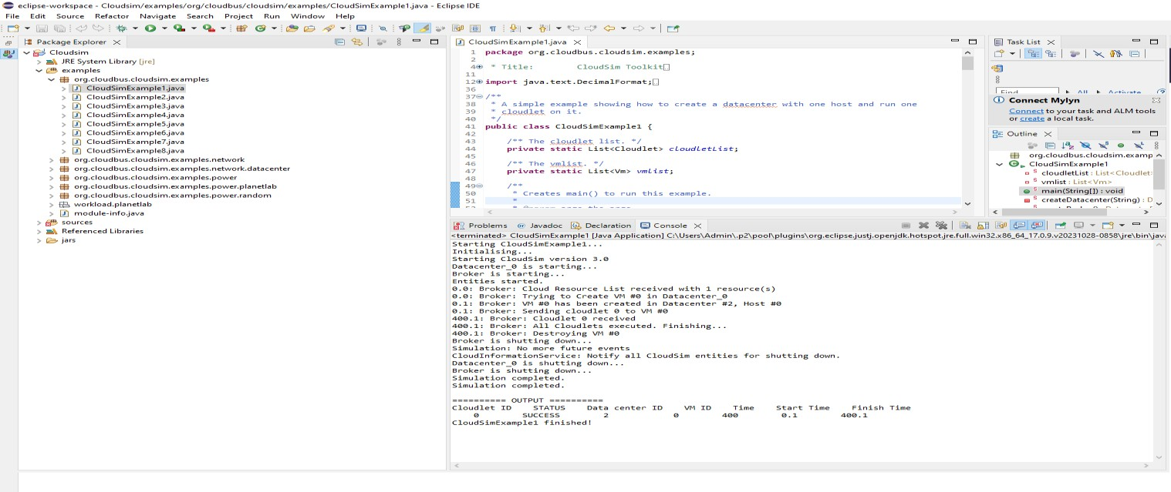

**Result:** Thus the simulation of cloud scenario using CloudSim has been done successfully.

### Find a procedure to transfer the files from one virtual machine to another virtual machine.

**Aim:** To find a procedure to transfer the files from one virtual machine to another virtual machine.

### Procedure:

Step-1: Go to Ubuntu and search for terminal and give the following command to install ssh

### sudo apt install openssh.server

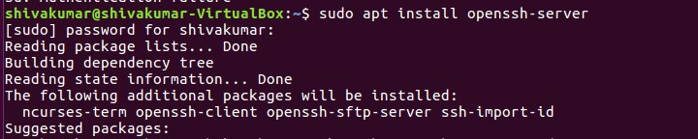

Step-2: Now go to Browser and search for “Download WinSCP” Step-3: Now go to first Website and download the winscp

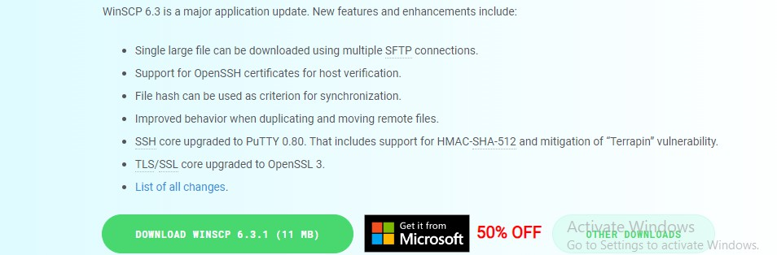

Step-4: Once if the file gets downloaded then install it

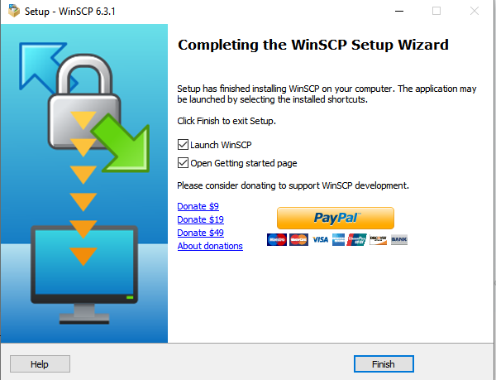.

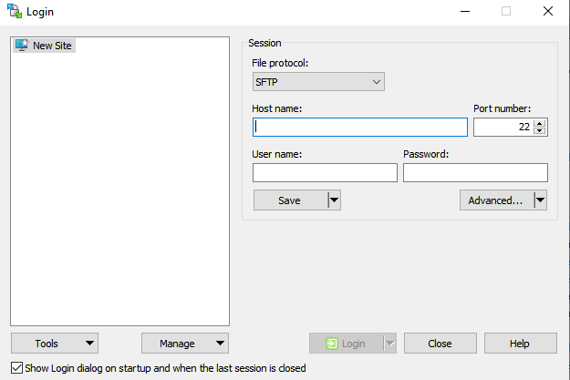Step-5: Here we have to give the IP Address of my host machine

Step-6: Now go to Ubuntu terminal again

Step-7: Go to Devices→Network→Network Settings and select Bridge Adapter as shown below and click OK.

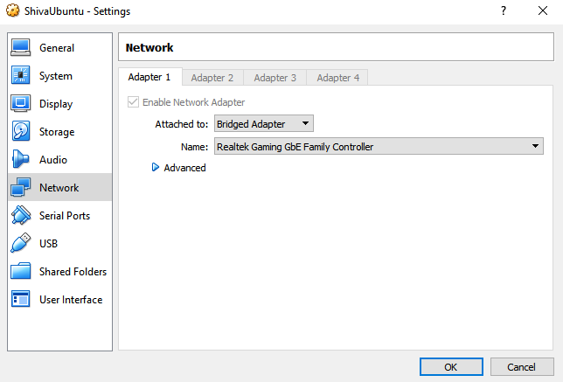

Step-8: Again go to terminal and give **ifconfig** command to get the ip address as shown below

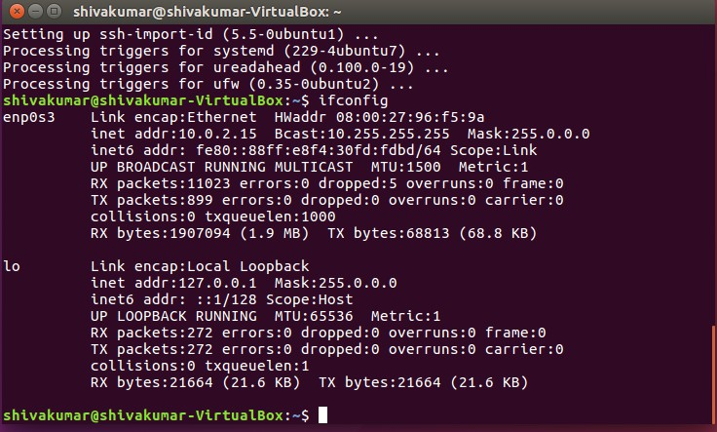

Step-9: Get the ip address and go WinSCP and fill the ip address here as shown by giving a user name and password.

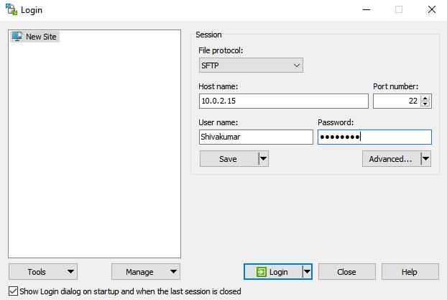

Step-10: Now we can see two different Host machine with all the files.

Step-11: Drag and drop the file which you need to transfer from one host to another.

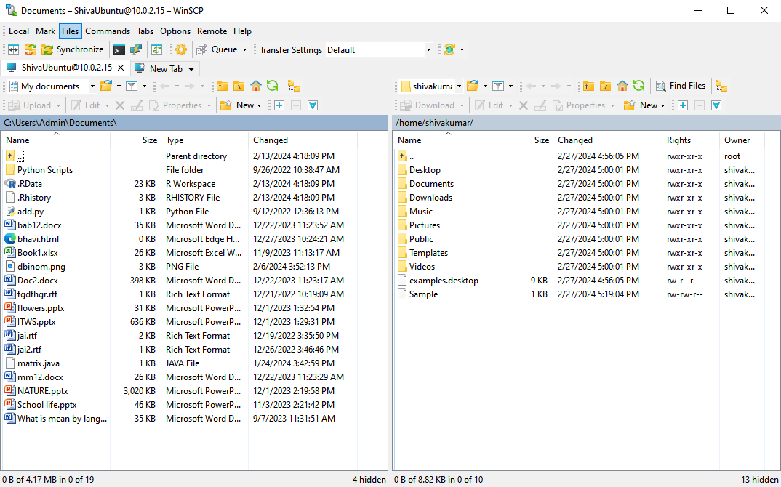

Step-12: Now go to your host machine and check for the file.(Now, here you can observe the file “sample” is transferred from our Ubuntu Host Machine to Windows Host).

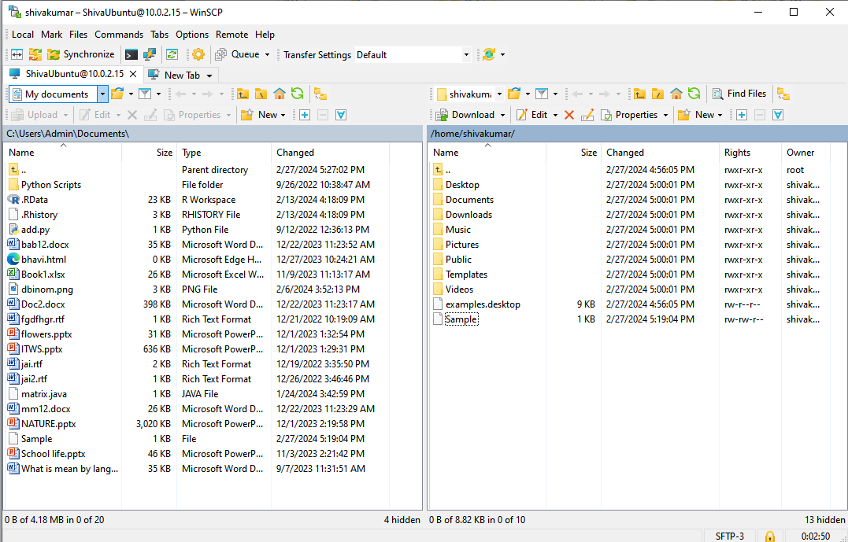

**Result**: Thus, Transfer of the files from one virtual machine to another virtual machine has been done successfully.

1. **Find a procedure to launch virtual machine using trystack (Online Openstack Demo Version). Aim:** To launch virtual machine using trystack.

### Procedure:

**OpenStack** is an open-source software cloud computing platform. OpenStack is primarily used for deploying an infrastructure as a service (IaaS) solution like Amazon Web Service (AWS). In other words, you can *make your own AWS* by using OpenStack. If you want to try out OpenStack, **TryStack** is the easiest and free way to do it.

In order to try OpenStack in TryStack, you must register yourself by joining TryStack Facebook Group. The acceptance of group needs a couple days because it’s approved manually. After you have been accepted in the TryStack Group, you can log in TryStack.

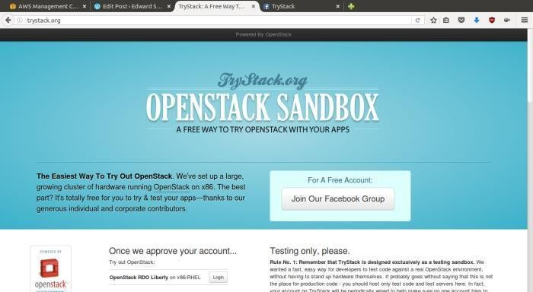

### TryStack.org Homepage

I assume that you already join to the Facebook Group and login to the dashboard. After you log in to the TryStack, you will see the Compute Dashboard like:

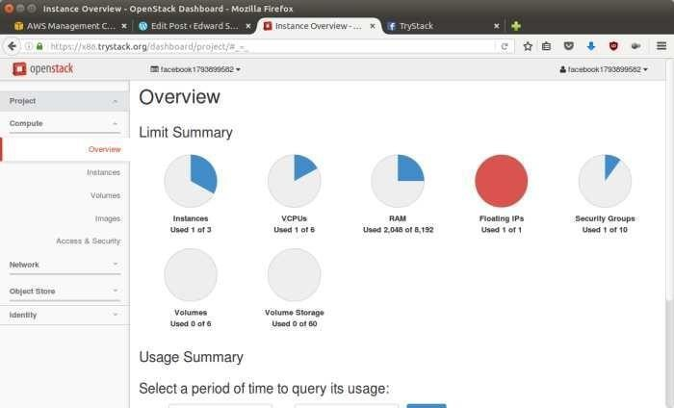

### OpenStack Compute Dashboard

**Overview: What we will do?**

Here let us find how to run an OpenStack instance. The instance will be accessible through the internet (have a public IP address). The final topology will like:

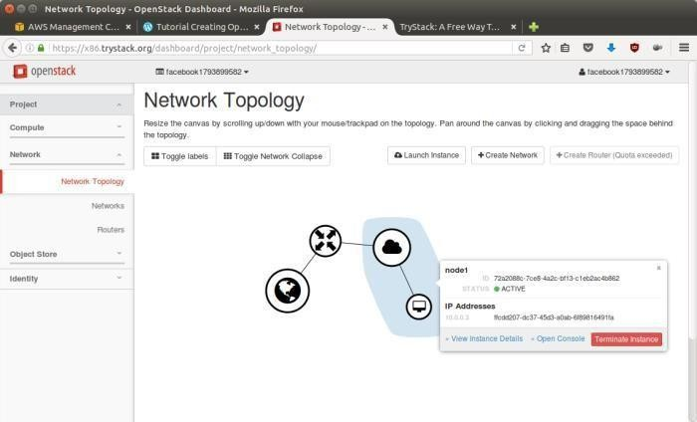

### Network topology

As you see from the image above, the instance will be connected to a local network and the local network will be connected to internet.

### Step 1: Create Network

Network? Yes, the network in here is our own local network. So, your instances will be not mixed up with the others. You can imagine this as your own LAN (Local Area Network) in the cloud.

1. Go to **Network > Networks** and then click **Create Network**.
2. In **Network** tab, fill **Network Name** for example internal and then click **Next**.
3. In **Subnet** tab,
4. Fill **Network Address** with appropriate CIDR, for example 192.168.1.0/24. Use private network CIDR block as the best practice.
5. Select **IP Version** with appropriate IP version, in this case IPv4.
6. Click **Next**.
7. In **Subnet Details** tab, fill **DNS Name Servers** with 8.8.8.8 (Google DNS) and then click **Create**.

### Step 2: Create Instance

Now, we will create an instance. The instance is a virtual machine in the cloud, like AWS EC2. You need the instance to connect to the network that we just created in the previous step.

1. Go to **Compute > Instances** and then click **Launch Instance**.
2. In **Details** tab,
   * Fill **Instance Name**, for example Ubuntu 1.
   * Select **Flavor**, for example m1.medium.
   * Fill **Instance Count** with **1**.
   * Select **Instance Boot Source** with **Boot from Image**.
   * Select **Image Name** with **Ubuntu 14.04 amd64 (243.7 MB)** if you want install Ubuntu 14.04 in your virtual machine.
3. In **Access & Security** tab,
   * Click [**+**] button of **Key Pair** to import key pair. This key pair is a public and private key that we will use to connect to the instance from our machine.
   * In **Import Key Pair** dialog,
     + Fill **Key Pair Name** with your machine name (for example Edward-Key).
     + Fill **Public Key** with your **SSH public key** (usually is in ~/.ssh/id_rsa.pub). See description in Import Key Pair dialog box for more information. If you are using Windows, you can use **Puttygen** to generate key pair.
     + Click **Import key pair**.
   * In **Security Groups**, mark/check **default**.
   * In **Networking** tab,
     + In **Selected Networks**, select network that have been created in Step 1, for example internal.
   * Click **Launch**.
   * If you want to create multiple instances, you can repeat step 1-5. I created one more instance with instance name Ubuntu 2.

### Step 3: Create Router

I guess you already know what router is. In the step 1, we created our network, but it is isolated. It

doesn’t connect to the internet. To make our network has an internet connection, we need a router that running as the gateway to the internet.

1. Go to **Network > Routers** and then click **Create Router**.
2. Fill **Router Name** for example router1 and then click **Create router**.
3. Click on your **router name link**, for example router1, **Router Details** page.
4. Click **Set Gateway** button in upper right:
   * Select **External networks** with **external**.
   * Then OK.
5. Click **Add Interface** button.
   * Select **Subnet** with the network that you have been created in Step 1.
   * Click **Add interface**.
6. Go to **Network > Network Topology**. You will see the network topology. In the example, there are two network, i.e. external and internal, those are bridged by a router. There are instances those are joined to internal network.

### Step 4: Configure Floating IP Address

*Floating IP address* is public IP address. It makes your instance is accessible from the internet. When you launch your instance, the instance will have a private network IP, but no public IP. In OpenStack, the public Ips is collected in a pool and managed by admin (in our case is TryStack). You need to request a public (floating) IP address to be assigned to your instance.

1. Go to **Compute > Instance**.
2. In one of your instances, click **More > Associate Floating IP**.
3. In **IP Address**, click Plus [**+**].
4. Select **Pool** to **external** and then click **Allocate IP**.
5. Click **Associate**.
6. Now you will get a public IP, e.g. 8.21.28.120, for your instance.

### Step 5: Configure Access & Security

OpenStack has a feature like a firewall. It can whitelist/blacklist your in/out connection. It is called Security Group.

1. Go to **Compute > Access & Security** and then open **Security Groups** tab.
2. In **default** row, click **Manage Rules**.
3. Click **Add Rule**, choose **ALL ICMP** rule to enable ping into your instance, and then click **Add**.
4. Click **Add Rule**, choose **HTTP** rule to open HTTP port (port 80), and then click **Add**.
5. Click **Add Rule**, choose **SSH** rule to open SSH port (port 22), and then click **Add**.
6. You can open other ports by creating new rules.

### Step 6: SSH to Your Instance

Now, you can SSH your instances to the floating IP address that you got in the step 4. If you are using Ubuntu image, the SSH user will be ubuntu.

### Result:

Thus the openstack demo worked successfully

1. **Install Hadoop single mode cluster and run simple applications. Aim:** To install Hadoop single mode cluster and run simple applications

### Procedure:

Update the packages

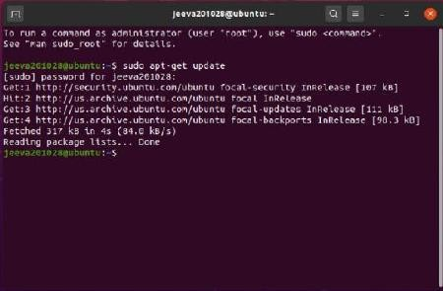

Installing java

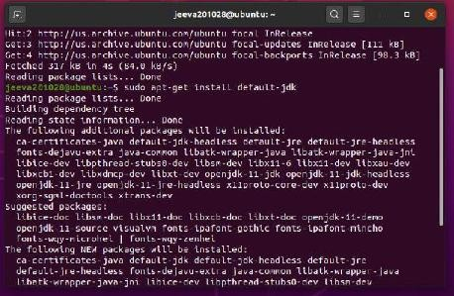

Assigning a dedicated user on hadoop to perform operations

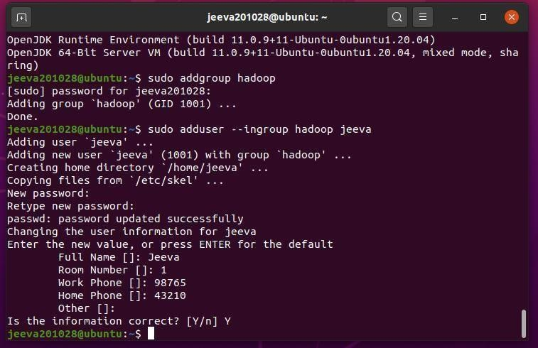

Adding user to sudo list

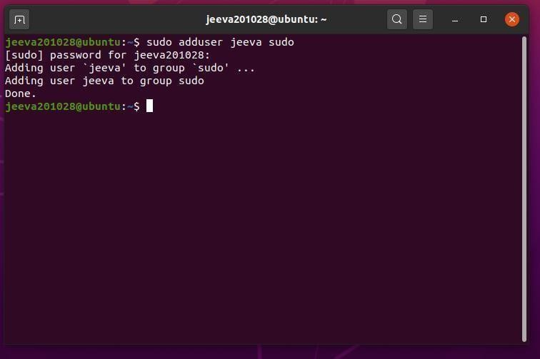

Next install a package ssh(secured shell login)

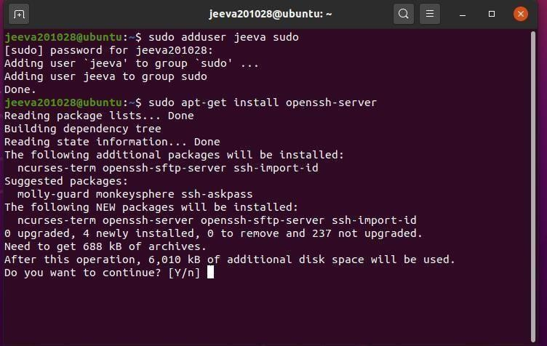

Next step is key generation and add a key to the file

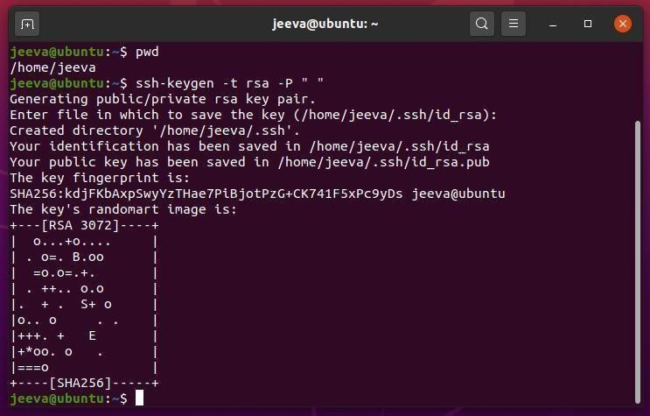

To check whether ssh is installed properly by logging in and after that exit from it

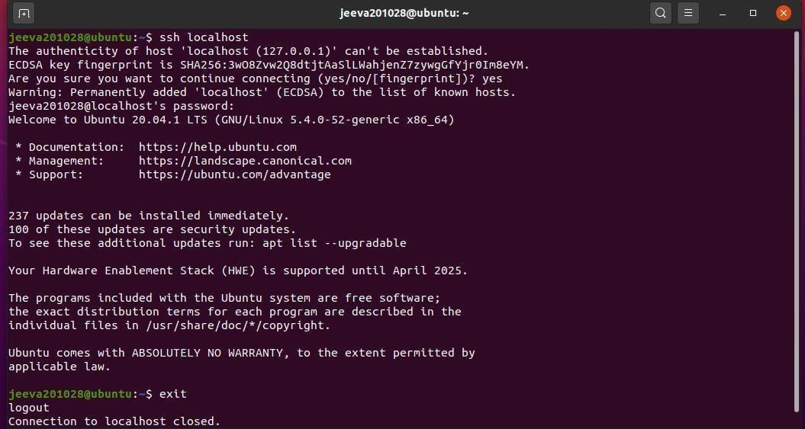

Download Hadoop using this link : <https://downloads.apache.org/hadoop/common/>

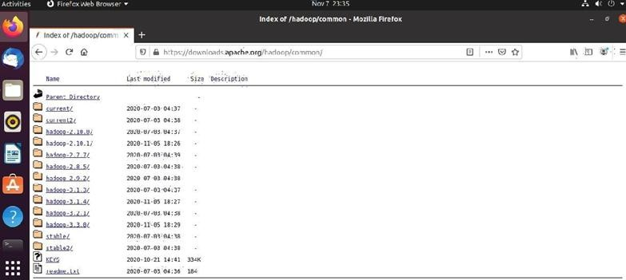

Download the hadoop-2.9.2.tar.gz file

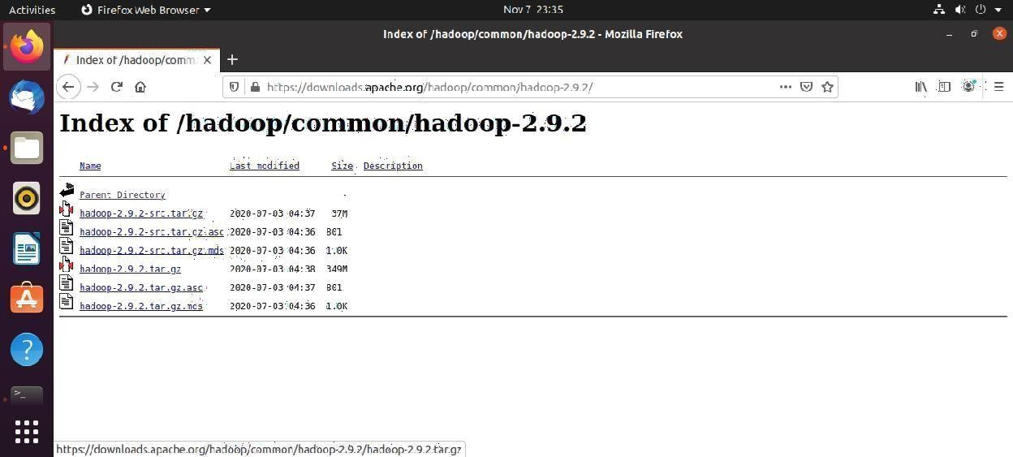

Now extract the tar file

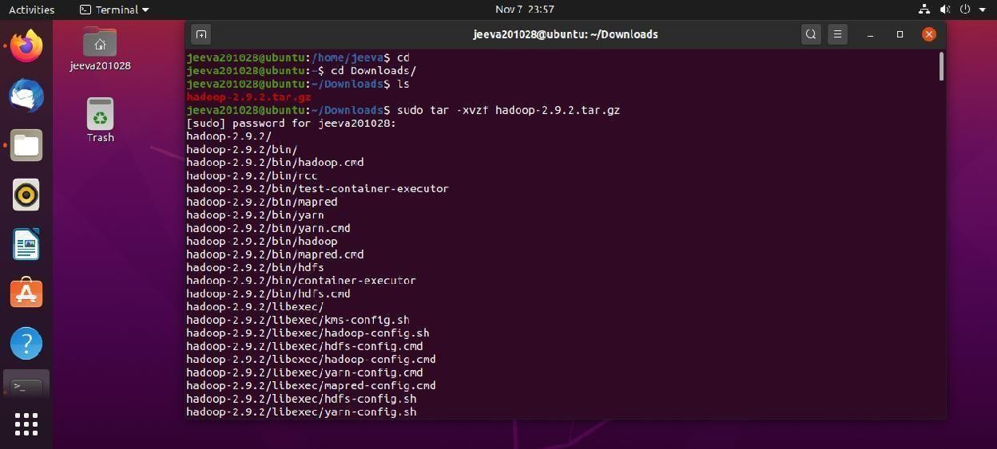

Move the file to local and Change the ownership of hadoop folder

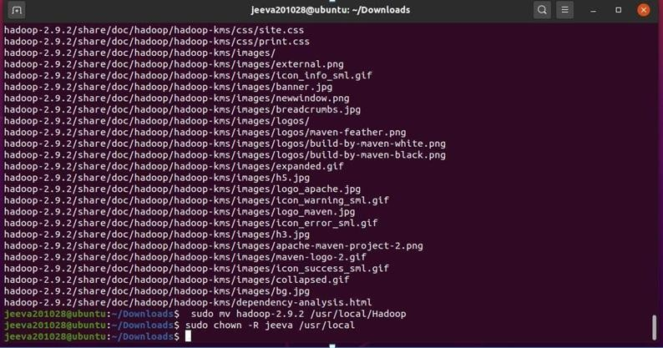

In .bashrc file add the following and make it at source

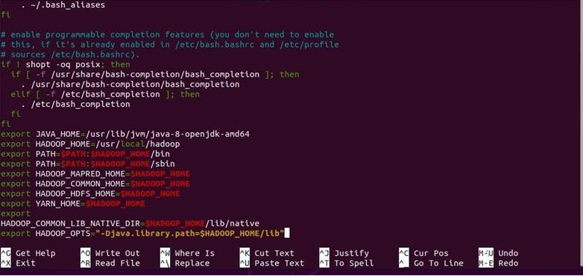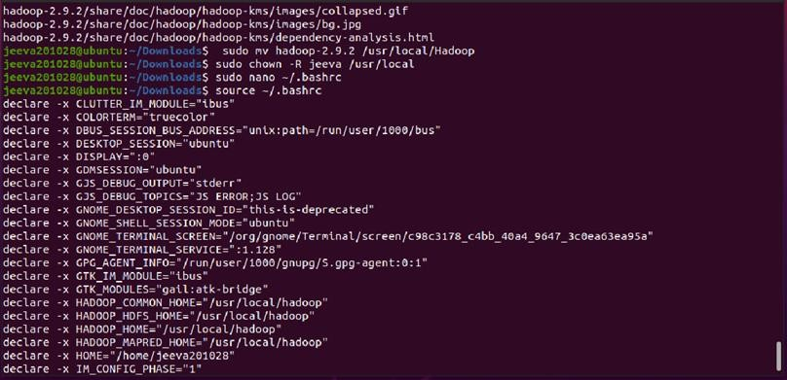

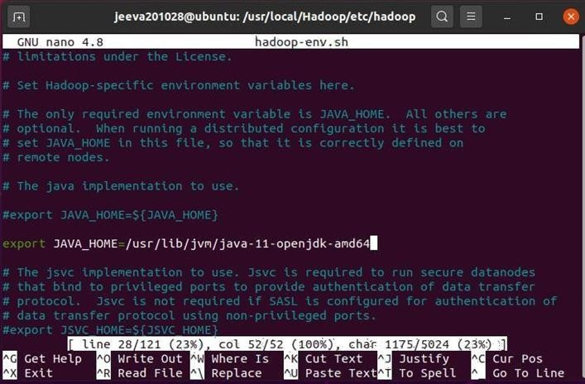Edit the hadoop-env.sh file as following

Edit the core-site.xml

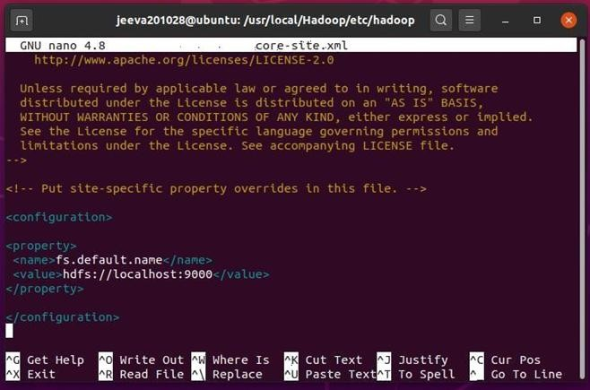

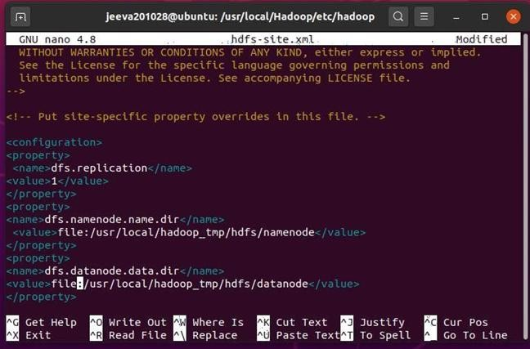Edit the hdfs-site.xml

Edit the yarn-site.xml

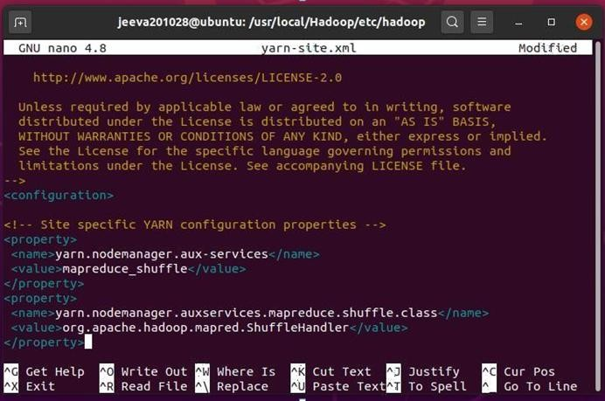

Edit the mapred-site.xml by remaning the mapred-site.xml.template

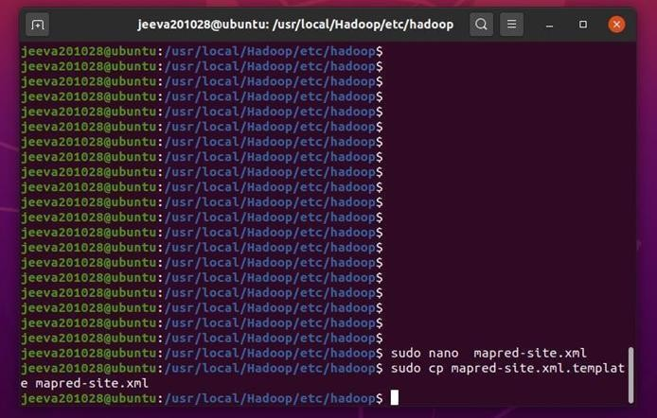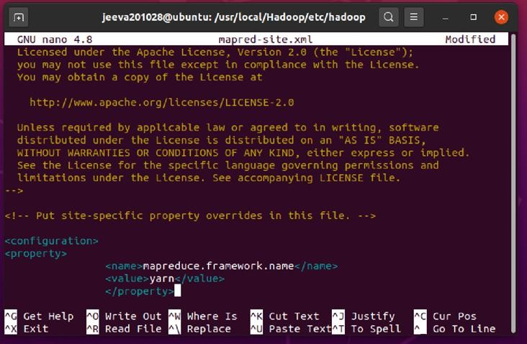

Create the following directory

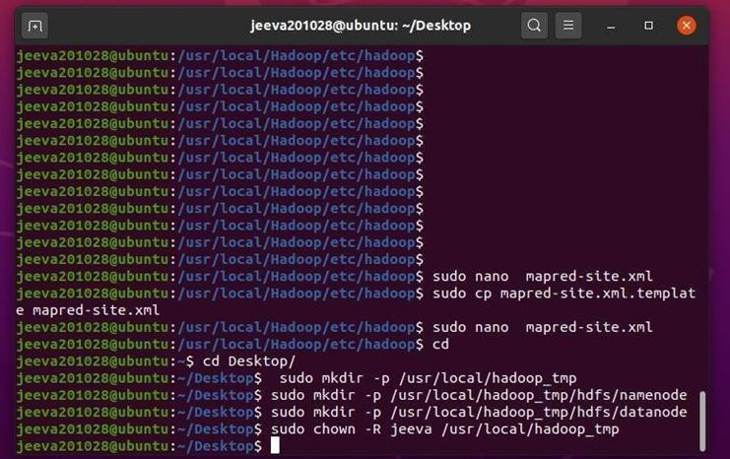

Format hdfs namenode

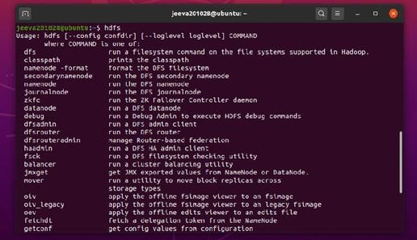

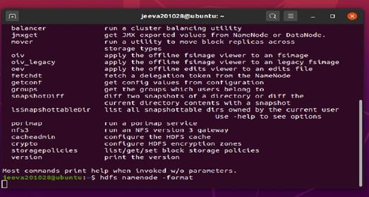

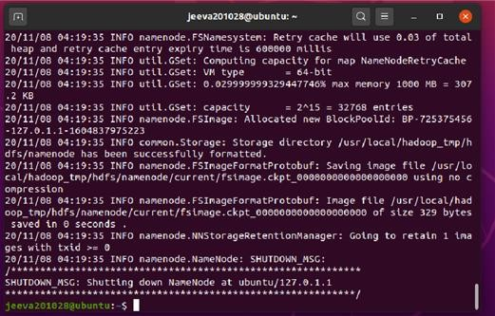

$ start-dfs.sh

$ start-yarn.sh

To check whether hadoop is correctly installed or not: $ jps

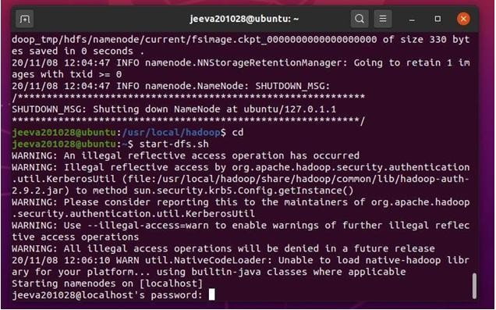

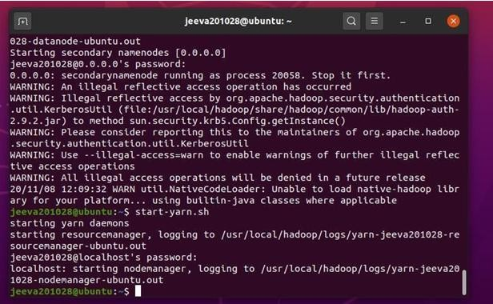

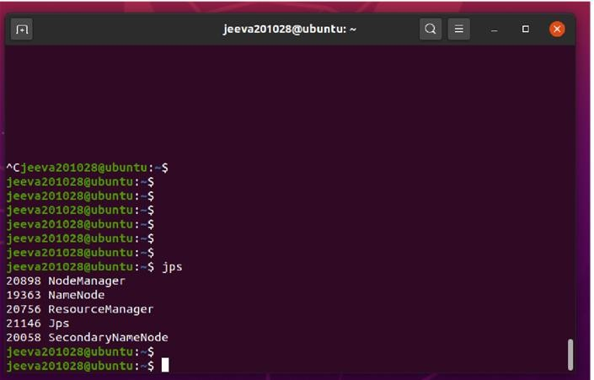

To execute word count program:

Create a directory and add a text file in it named “sample.txt”

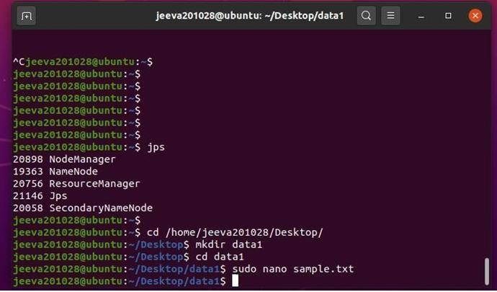

### Input: ‘sample.txt” file

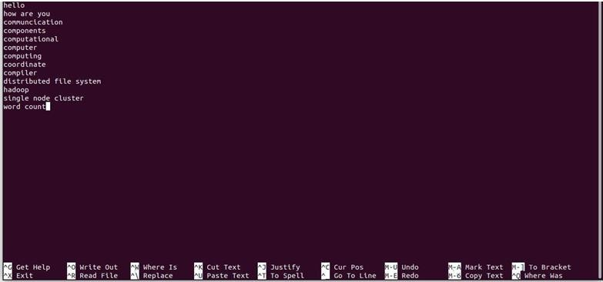

Now run **bin/hdfs dfs -mkdir /user**

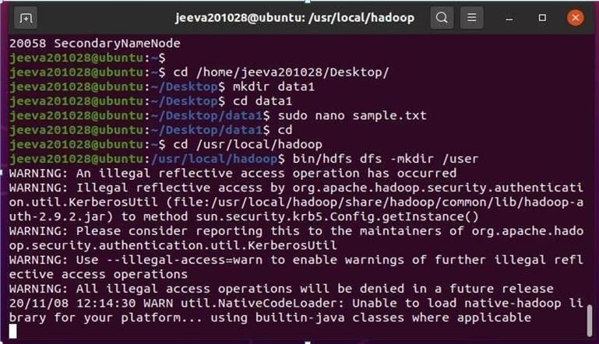

Then run **bin/hdfs dfs -mkdir /ypm**

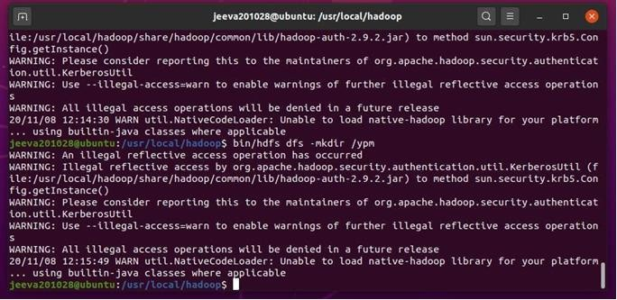

Run the program //word count prgm will be in the jar file by default which we are using now.

$ bin/hadoop jar share/hadoop/mapreduce/hadoop-mapreduce-examples- 2.9.2.jarwordcount /user/input output

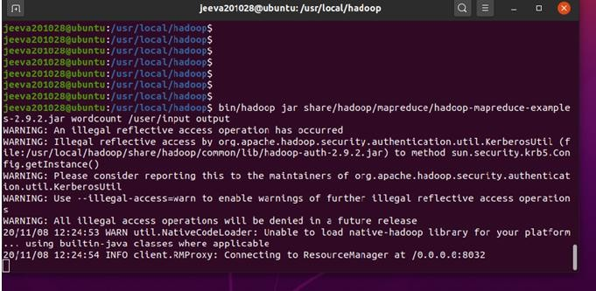

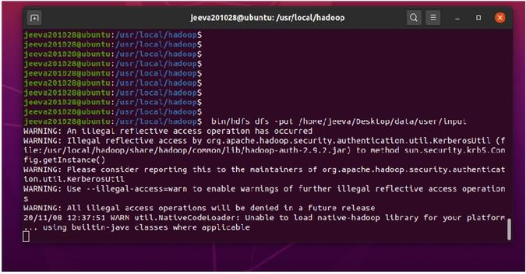

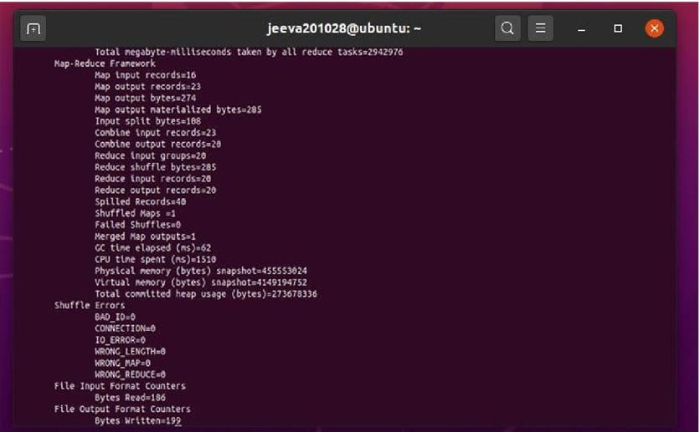

Now run the following command to see the output

$ bin/hdfs dfs -cat output/*

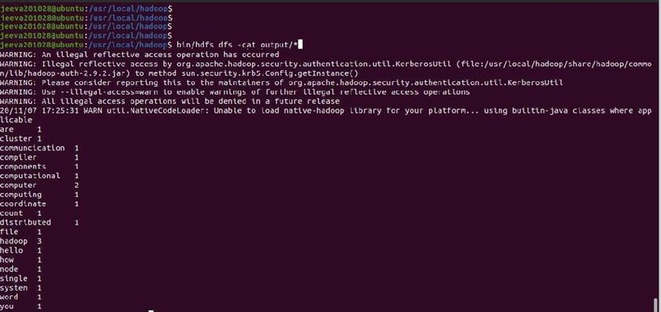

Using gui:In browser open port 50700, <http://localhost/50070> (Hadoop must be running)

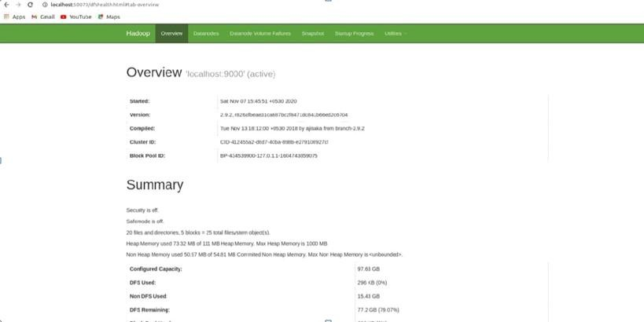

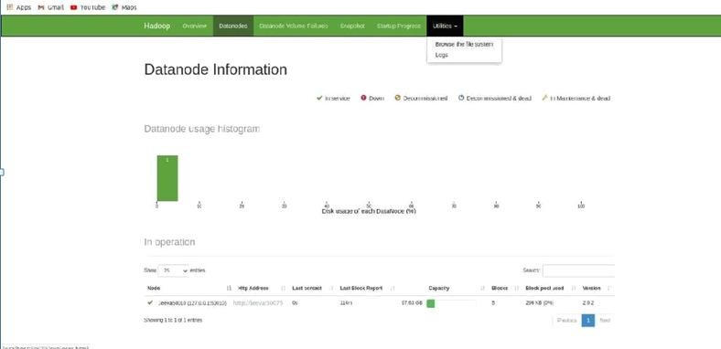

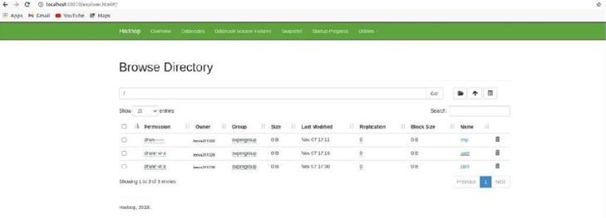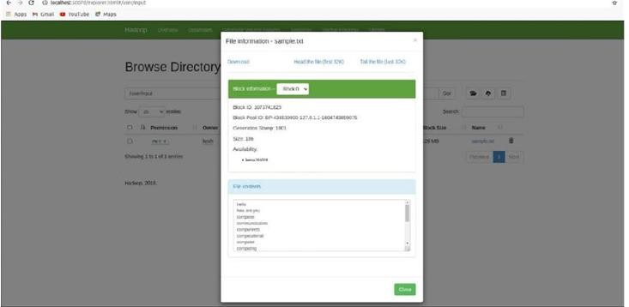

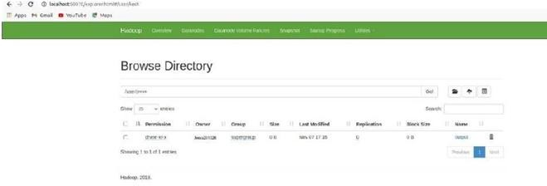

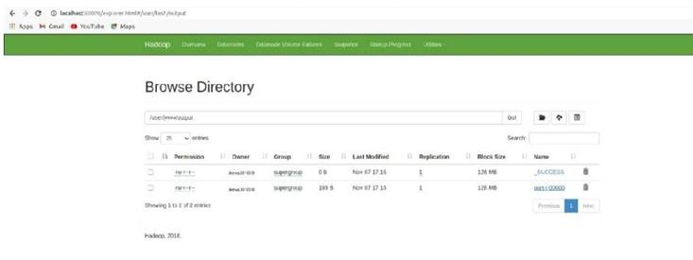

After completing stop hadoop $ stop-all.sh

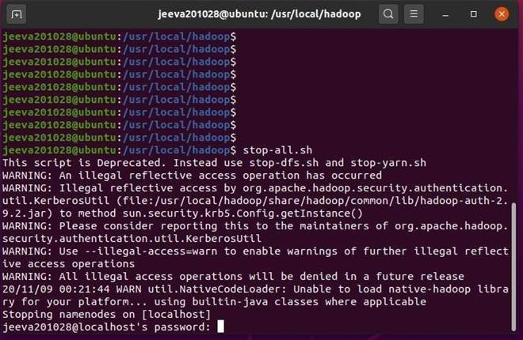

**Result:** Thus the installation of Hadoop single mode cluster and execution of word count program is done and the output is obtained successfully

1. **Establish an AWS account. Use the AWS Management Console to launch an EC2 instance and connect to it.**

**Aim: To Establish a connection with EC2 instance in AWS. Procedure:**

**How to Use AWS EC2**

**Step 1** − Sign-in to AWS account and open IAM console by using the following link https://console.aws.amazon.com/iam/.

**Step 2** − In the navigation Panel, create/view groups and follow the instructions.

**Step 3** − Create IAM user. Choose users in the navigation pane. Then create new users and add users to the groups.

**Step 4** − Create a Virtual Private Cloud using the following instructions.

* Open the Amazon VPC console by using the following link − https://console.aws.amazon.com/vpc/
* Select VPC from the navigation panel. Then select the same region in which we have created key-pair.
* Select start VPC wizard on VPC dashboard.
* Select VPC configuration page and make sure that VPC with single subnet is selected. The choose Select.
* VPC with a single public subnet page will open. Enter the VPC name in the name field and leave other configurations as default.

### Select create VPC, then select Ok.

**Step 5** − Create WebServerSG security groups and add rules using the following instructions. On the VPC console, select Security groups in the navigation panel.

Select create security group and fill the required details like group name, name tag, etc. Select your VPC ID from the menu. Then select yes, create button.

Now a group is created. Select the edit option in the inbound rules tab to create rules.

**Step 6 −** Launch EC2 instance into VPC using the following instructions.

Open EC2 console by using the following link − https://console.aws.amazon.com/ec2/ Select launch instance option in the dashboard.

A new page will open. Choose Instance Type and provide the configuration. Then select Next: Configure Instance Details.

### A new page will open. Select VPC from the network list. Select subnet from the subnet list and leave the other settings as default. Click Next until the Tag Instances page appears.

**Step 7 −** On the Tag Instances page, provide a tag with a name to the instances. Select Next: Configure Security Group.

**Step 8 −** On the Configure Security Group page, choose the Select an existing security group option. Select the WebServerSG group that we created previously, and then choose Review and Launch.

**Step 9 −** Check Instance details on Review Instance Launch page then click the Launch button.

**Step 10 −** A pop up dialog box will open. Select an existing key pair or create a new key pair. Then select the acknowledgement check box and click the Launch Instances button.

**Result:** Thus EC2 Instance is launched successfully with AWS.

### Develop a Guestbook Application using Google App Engine.

**Aim:** To Develop a Guestbook Application using Google App Engine.

### Procedure:

Guestbook is an example application showing basic usage of Google App Engine. Users can read & write text messages and optionally log-in with their Google account. Messages are stored in App Engine (NoSQL) High Replication Datastore (HRD) and retrieved using a strongly consistent (ancestor) query.

Guestbook is a sample application that records visitors' messages and displays a cloud banner with an administrative message. The main business logic is written in a cloud-agnostic manner using MySQL, the generic blob API, and the generic runtimevar API. All platform-specific code is set up by Wire.

# Prerequisites

You will need to install the following software for this tutorial:

* [Git](https://git-scm.com/)
* [Go](https://golang.org/doc/install)
* [Wire](https://github.com/google/wire/blob/master/README.md#installing)
* [Docker Desktop](https://docs.docker.com/install/)
* [Terraform](https://www.terraform.io/intro/getting-started/install.html)

**Cloning the Sample**

Before you can do anything else, you need to clone the Go CDK repository. The repository contains the Guestbook sample.

git clone https://github.com/google/go-cloud.git cd go-cloud/samples/guestbook

**Building**

Run the following in the samples/guestbook directory:

go generate && go build

**Running Locally**

You will need to run a local MySQL database server and create a local message of the day. localdb/main.go runs the local MySQL database server using Docker:

go get ./localdb/... *# Get package dependencies.*

go run localdb/main.go

In another terminal, run the guestbook application:

|  |  |
| --- | --- |
|  |  |
|  | *# Set a local Message of the Day.*  echo 'Hello, World!' > motd.txt  *# Run the server.*  *# For blob, it uses fileblob, pointing at the local directory ./blobs.*  *# For runtimevar, it uses filevar, pointing at the local file ./motd.txt. # You can update the ./motd.txt while the server is running, refresh # the page, and see it change.*  ./guestbook -env=local -bucket=blobs -motd_var=motd.txt |
| Your server is now running on [http://localhost:8080/.](http://localhost:8080/)  You can stop the MySQL database server with Ctrl-\. MySQL ignores Ctrl-C (SIGINT).  **Running on Google Cloud Platform (GCP)**  If you want to run this sample on GCP, you need to create a project, download the [gcloud CLI](https://cloud.google.com/sdk/downloads), install kubectl and log in. | |
|  | *# Install kubectl.*  gcloud components install kubectl  *# Opens a browser to log you into GCP.*  gcloud auth login |
| **Provision resources**  You can now use Terraform to set up your project. | |
|  | gcloud auth application-default login cd gcp  terraform init  *# Terraform will prompt you for your GCP project ID, desired region, # and desired zone.*  terraform apply |
| **Deploy the application**  This sample provides a script for building the Guestbook binary and deploying it to the Kubernetes cluster created by Terraform. | |
|  | go run deploy/main.go |
| The deploy script will display the URL of your running service.  **Cleanup**  To clean up the created resources, run terraform destroy inside the gcp directory using the same variables you entered during terraform apply. | |

# Running on Amazon Web Services (AWS)

If you want to run this sample on AWS, you need to set up an account, download the [AWS command](https://docs.aws.amazon.com/cli/latest/userguide/installing.html) [line interface,](https://docs.aws.amazon.com/cli/latest/userguide/installing.html) and log in. There’s [help here](https://docs.aws.amazon.com/cli/latest/userguide/cli-chap-configure.html) if you need it.

aws configure

## Agree to the Debian Terms and Conditions

You have to agree to the [Debian Terms and Conditions](https://aws.amazon.com/marketplace/pp?sku=55q52qvgjfpdj2fpfy9mb1lo4) in order to provision the resources. Click through the “Continue to Subscribe” button at the top, then log in to your AWS account and subscribe to Debian.

## SSH Key

You will also need an SSH key to SSH into the EC2 instance. If you don’t already have one, you can follow [this guide from GitHub](https://help.github.com/articles/generating-a-new-ssh-key-and-adding-it-to-the-ssh-agent/). Follow the instructions for “Adding your key to the ssh-agent” if you want the key to persist across terminal sessions.

ssh-add

## Provision resources

You can now use Terraform to set up your project. This will create an EC2 instance you can SSH to and run your binary.

*# Build for deploying on the AWS Linux VM.*

GOOS=linux GOARCH=amd64 go build

*# Enter AWS directory from samples/guestbook.*

cd aws terraform init

*# Provisioning can take up to 10 minutes.*

*# Keep track of the output of this command as it is needed later. # You can replace us-west-1 with whatever region you want.*

terraform apply -var region=us-west-1 -var ssh_public_key="**$(**cat ~/.ssh/id_rsa.pub**)**"

## Deploy the application

You now need to connect to the new remote server to execute the guestbook binary. The final output of terraform apply lists the variables guestbook requires as arguments. Here’s an example, with actual strings replaced with [redacted]:

*# Output from "terraform apply" command....*

<snip>

Outputs:

|  |  |
| --- | --- |
|  |  |
|  | bucket = [redacted] database_host = [redacted]  database_root_password = <sensitive> instance_host = [redacted] paramstore_var = /guestbook/motd region = us-west-1  *# Print out the database root password, since we'll need it below # Terraform hides it by default in the Outputs above.*  localhost$ terraform output database_root_password [redacted]  *# SSH into the EC2 instance.*  localhost$ ssh "admin@**$(** terraform output instance_host **)**"  *# Fill in each command-line argument with the values from the*  *# Terraform output above.*  server$ AWS_REGION=<your region> ./guestbook **\**  -env=aws **\**  -bucket=<your bucket> **\**  -db_host=<your database_host> **\**  -db_user=root **\**  -db_password=<your database_root_password> **\**  -motd_var=/guestbook/motd |
| You can now visit the server at http://<your instance_host>:8080/.  **Cleanup**  To clean up the created resources, run terraform destroy inside the aws directory using the same variables you entered during terraform apply.  **Running on Azure**  The Go CDK doesn’t have support for SQL on Azure yet ([#1305](https://github.com/google/go-cloud/issues/1305)), so we’ll run MySQL and the binary locally. This tutorial will show how to use Azure storage for the MOTD and Gopher logo.  You first need to set up an Azure account and install the [Azure CLI.](https://docs.microsoft.com/en-us/cli/azure/install-azure-cli?view=azure-cli-latest) Then, use the az CLI to log in. | |
|  | az login |
| **Provision resources**  We’ll use Terraform to set up your project. | |
|  | *# Enter the Azure directory from samples/guestbook.*  cd azure terraform init  *# Provisioning can take up to 10 minutes.* |
|  | |

|  |  |
| --- | --- |
|  |  |
|  | *# Keep track of the output of this command as it is needed later.*  terraform apply -var location="West US"  <snip> Outputs:  access_key = [redacted] storage_account = [redacated] storage_container = [redacted] |
| **Deploy the application**  You will need to run a local MySQL database server, similar to what we did for running locally earlier. Open a new terminal window, and run: | |
|  | cd .. *# back up to samples/guestbook*  go get ./localdb/... *# Get package dependencies.*  go run localdb/main.go |
| In the original terminal, add your Azure credentials to the environment and run the guestbook application: | |
|  | *# You should be in the "samples/guestbook/azure" directory.*  *# Enter the storage_account from the Terraform output earlier.* export AZURE_STORAGE_ACCOUNT=<your storage_account> *# Enter the access_key from the Terraform output earlier.*  export AZURE_STORAGE_KEY=<your access_key>  *# Run the binary.*  *# Fill in the -bucket command-line argument with the value from the Terraform # output.*  *#*  ./guestbook -env=azure -bucket=<your storage_container> -motd_var=motd |
| Your server is now running on [http://localhost:8080/.](http://localhost:8080/)  You can stop the MySQL database server with Ctrl-\. MySQL ignores Ctrl-C (SIGINT).  **Cleanup**  To clean up the created resources, run terraform destroy inside the azure directory using the same variables you entered during terraform apply.  **Result:** Thus, The above procedure implements the Guestbook application successfully**.** | |

1. **Develop a Serverless Web App using AWS Aim:** To Develop a Serverless Web App using AWS

### Procedure:

**What is a serverless web app?**

If you are interested in building a web app without worrying about servers, scalability, or maintenance, then you might want to consider building a serverless web app on AWS. It is a web application that runs on the cloud without requiring any servers to host or manage it. Instead, it relies on serverless computing services, such as AWS Lambda, to execute the backend logic and interact with other cloud resources.

### Why should you use AWS Lambda?

AWS Lambda is a service that lets you run code without provisioning or managing servers. With Lambda, you can run code for virtually any type of application or backend service. You can also use Lambda to integrate with other AWS services, such as Amazon S3, Amazon DynamoDB, Amazon API Gateway, and more. You will be able to create a simple web page that allows users to enter their name and email address, and store them in a DynamoDB table.

We will also use API Gateway to create an endpoint that invokes the Lambda function and returns the data to the web page. By the end of this blog, you will have a basic understanding of AWS serverless [web app architecture](https://www.calibraint.com/blog/web-application-architecture) and how to build a serverless web application in AWS.

Let’s get started with the steps to building a serverless web app on AWS. What do you need to get started to build a serverless web app?

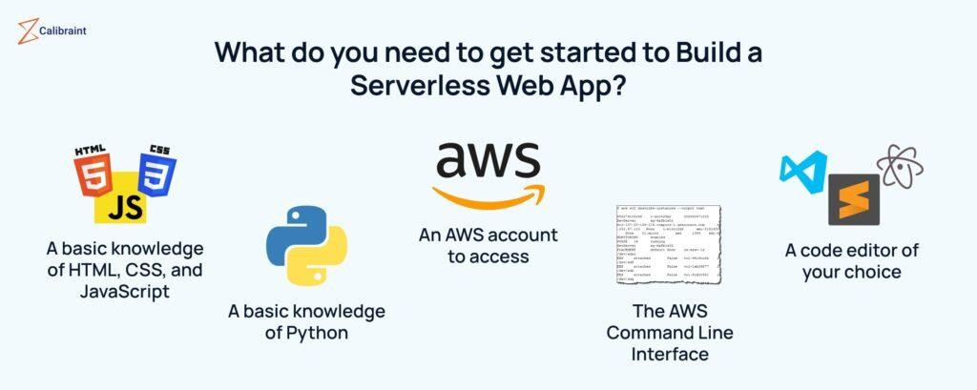

Before getting started with the project, I will list out the prerequisites that you will need to start building your first serverless web app.

* A basic knowledge of HTML, CSS, and JavaScript as you will be using these languages to create the front end of your web app.
* A basic knowledge of Python so that you can write the Lambda function that handles the backend logic of your web app.
* An AWS account to access and use the AWS services that we will use in this project.
* The AWS Command Line Interface to interact with the AWS services from your terminal. If you don’t have one you can install and configure it with these [instructions](https://docs.aws.amazon.com/cli/latest/userguide/getting-started-install.html).
* A code editor of your choice. I would recommend Visual Studio Code, Atom, Sublime Text, etc.

Getting started with Building a Serverless Web App with AWS Lambda

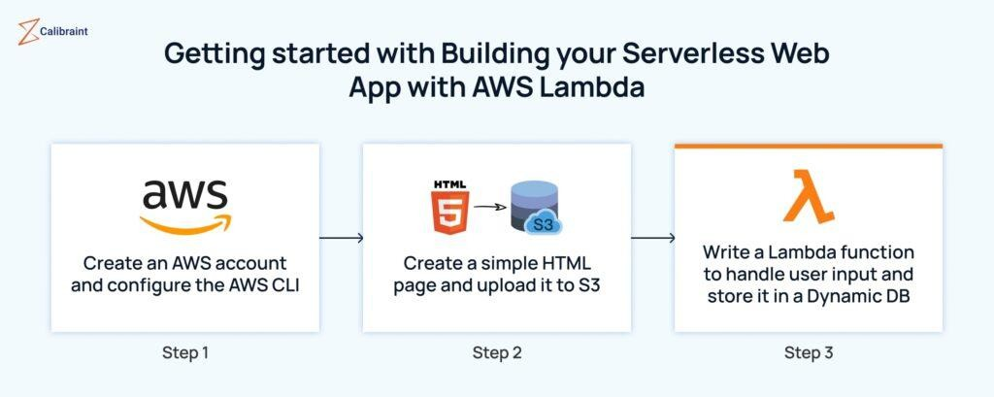

### Step 1: Create an AWS account and configure the AWS CLI

In order to start building a serverless web app on AWS you should first create an AWS account and configure the AWS CLI. This will allow you to access and use the AWS services that we will need for this project. I would suggest you to follow these steps:

* Go to the [AWS homepage](https://aws.amazon.com/) and click on the Create button to get started.
* Enter your official details wherever necessary.
* Choose the Personal or Professional account type, depending on your preference.
* Enter your payment information. You will need a valid credit card or debit card to create an AWS account. (Don’t worry, you will not be charged unless you exceed the free tier limits of the AWS services that you use)
* Verify your identity by entering a code that will be sent to your phone number or email address.
* Choose a plan that suits your requirements to proceed further. I would suggest you go through each of them to learn more about the features and benefits, such as technical support, faster response times, and more.
* Once you complete the sign-up process you will see a confirmation page that welcomes you to AWS.

Now that you have created an account, proceed further to configure the AWS CLI.

* Install the AWS CLI on your computer by downloading it from the [official website](https://docs.aws.amazon.com/cli/latest/userguide/getting-started-install.html). Follow the on-screen instructions for your operating system to complete the installation.
* Open a terminal window (CMD or PowerShell) and run the command *aws configure*. You will be prompted to enter your AWS Access Key ID and AWS Secret Access Key, which are credentials that allow you to access and use the AWS services that you can find in your [AWS](https://aws.amazon.com/console/) [console.](https://aws.amazon.com/console/)
* You should also enter your AWS Region and Output Format as it will affect how the [AWS](https://aws.amazon.com/cli/) [CLI](https://aws.amazon.com/cli/) interacts with the AWS services. (If your region isn’t listed on the website, you can choose the one that is close to your location)
* Test your configuration by running the command *aws s3 ls*. This command lists all the S3 buckets in your account.
* If you see a list of buckets or an empty output, then your configuration is successful. However, if you see an error message, then you need to check your configuration and try again.

### Step 2: Create a simple HTML page and upload it to S3

The next step in building a serverless web app on AWS is to create a simple HTML page that will serve as the front end of your web app. You will be using HTML, CSS, and JavaScript to create a web page that allows users to enter their basic information and displays a message when they submit the form. You will also upload the HTML page to S3, which is a service that provides secure, durable, and scalable object storage.

Now you can proceed to create your first serverless web app:

* Open your code editor and create a new file named index.html.
* Copy and paste the following code into the file:

*<html>*

*<head>*

*<style>*

*body {*

*font-family: Arial, sans-serif; text-align: center;*

*}*

*h1 {*

*color: blue;*

*}*

*form {*

*}*

*margin: 20px auto; width: 300px;*

*input {*

*display: block; margin: 10px auto;*

*}*

*button {*

*background-color: green; color: white;*

*padding: 10px 20px; border: none; cursor: pointer;*

*}*

*#message { display: none; color: red;*

*}*

*</style>*

*</head>*

*<body>*

*<h1>Serverless Web App Demo</h1>*

*<form id=”form”>*

*<input type=”text” id=”name” placeholder=”Enter your name” required>*

*<input type=”email” id=”email address” placeholder=”Enter your email” required>*

*<button type=”submit”>Submit</button>*

*</form>*

*<p id=”message”>Thank you for submitting your details!</p>*

*<script>*

*// Get the form element*

*var form = document.getElementById(“form”);*

*// Add an event listener to handle the form submission form.addEventListener(“submit”, function(event) {*

*// Prevent the default form submission behavior event.preventDefault();*

*// Get the name and email values from the input elements var name = document.getElementById(“name”).value;*

*var email = document.getElementById(“email address”).value;*

*// Call the sendData function to send the data to the backend sendData(name, email address);*

*// Show the message element document.getElementById(“message”).style.display = “block”;*

*// Clear the input values document.getElementById(“name”).value = “”; document.getElementById(“email address”).value = “”;*

*});*

*// Define a function to send the data to the backend function sendData(name, email) {*

*// Create an XMLHttpRequest object var xhr = new XMLHttpRequest();*

*// Set the request method, URL, and asynchronous flag xhr.open(“POST”, “https://your-api-gateway-url”, true);*

*// Set the request header for the content type xhr.setRequestHeader(“Content-Type”, “application/json”);*

*// Define a callback function to handle the response*

*xhr.onreadystatechange = function() {*

*// Check if the request is completed if (xhr.readyState == 4) {*

*// Check if the status is OK if (xhr.status == 200) {*

*// Parse the response as JSON*

*var response = JSON.parse(xhr.responseText);*

*// Log the response to the console console.log(response);*

*} else {*

*// Log the error to the console console.error(xhr.statusText);*

*}*

*}*

*};*

*// Create a data object with the name and email properties var data = {*

*name: name,*

*email: email address*

*};*

*// Send the data as JSON string xhr.send(JSON.stringify(data));*

*}*

*</script>*

*</body>*

*</html>*

### Step 3: Write a Lambda function to handle user input and store it in a Dynamic DB

To proceed with building a serverless web app on AWS, you should write a Lambda function that will handle the user input and store it in DynamoDB. DynamoDB is a service that provides a fast and flexible NoSQL database. You can use DynamoDB to store the name and email address of the users who submit the form on your web page.

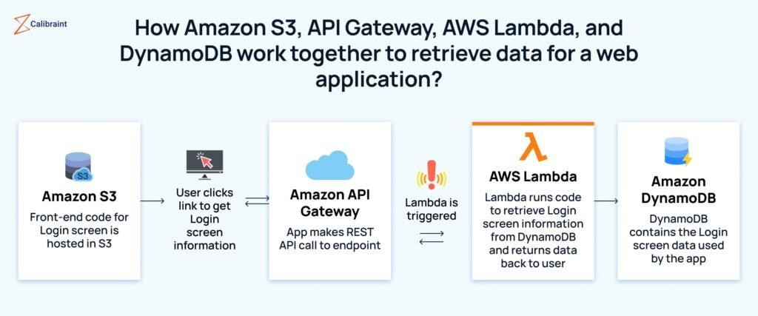

To write a Lambda function, follow these steps:

* Go to your AWS console and click on Lambda under Compute.
* Click on the Create function and choose Author from scratch.
* Enter a name for your function. You can use any name that you like, such as serverless-web- app-demo.
* Choose [Python 3.8](https://www.python.org/downloads/release/python-380/) as the runtime.
* Choose Create a new role with basic Lambda permissions as the execution role.
* Click on the Create function.
* In the code editor, delete the default code and copy and paste the following code:

*import json import boto3*

*# Create a DynamoDB resource dynamodb = boto3.resource(„dynamodb‟) # Get the table object*

*table = dynamodb.Table(„serverless-web-app-demo‟) # Define a handler function*

*def lambda_handler(event, context):*

*# Get the name and email from the event body name = event[„name‟]*

*email address‟= event[‟email‟] # Put the item into the table table.put_item(*

*Item={*

*„name‟: name,*

*‟email address‟: email*

*}*

*)*

*# Return a response with status code 200 and a message return {*

*„statusCode‟: 200,*

*„body‟: json.dumps(„Data saved successfully!‟)*

*}*

*import json import boto3*

*# Create a DynamoDB resource dynamodb = boto3.resource(„dynamodb‟) # Get the table object*

*table = dynamodb.Table(„serverless-web-app-demo‟) # Define a handler function*

*def lambda_handler(event, context):*

*# Get the name and email from the event body name = event[„name‟]*

*email address‟= event[‟email‟] # Put the item into the table table.put_item(*

*Item={*

*„name‟: name,*

*‟email address‟: email*

*}*

*)*

*# Return a response with status code 200 and a message return {*

*„statusCode‟: 200,*

*„body‟: json.dumps(„Data saved successfully!‟)*

*}*

*import json import boto3*

*# Create a DynamoDB resource dynamodb = boto3.resource(„dynamodb‟) # Get the table object*

*table = dynamodb.Table(„serverless-web-app-demo‟) # Define a handler function*

*def lambda_handler(event, context):*

*# Get the name and email from the event body name = event[„name‟]*

*email address‟= event[‟email‟] # Put the item into the table table.put_item(*

*Item={*

*„name‟: name,*

*‟email address‟: email*

*}*

*)*

*# Return a response with status code 200 and a message return {*

*„statusCode‟: 200,*

*„body‟: json.dumps(„Data saved successfully!‟)*

*}*

* Now save your file to ensure that you don’t lose your progress

Now that you have successfully created your Lambda function, it’s time to test it. Click on Test and choose Configure test events. Enter a name for your test event. You can use any name that you like, such as test-event. In the event template, delete the default JSON and copy and paste the following JSON:

{

“name”:“Vishaal”,

“emailaddress”:“[vishaal@example.com”](mailto:vishaal@example.com)

}

* Click on Create.
* Click on Test again and see the result. You should see a green banner that says Execution result: “Succeeded” and a response body that says “Data saved successfully!”.
* Go to your AWS console and click on DynamoDB under Database.
* Click on Tables and then click on serverless-web-app-demo.
* Click on Items and see the item that you just inserted. You should see an item with the name Vishaal and email address as [vishaal@example.com](mailto:vishaal@example.com).

### Step 4: Create an API Gateway endpoint to invoke the Lambda function

The final step in building a serverless web app on AWS is to create an API Gateway endpoint that invokes the Lambda function. API Gateway is a service that lets you create, manage, and secure APIs for your applications. You will have to use API Gateway to create a RESTful API that connects your web page to your Lambda function.

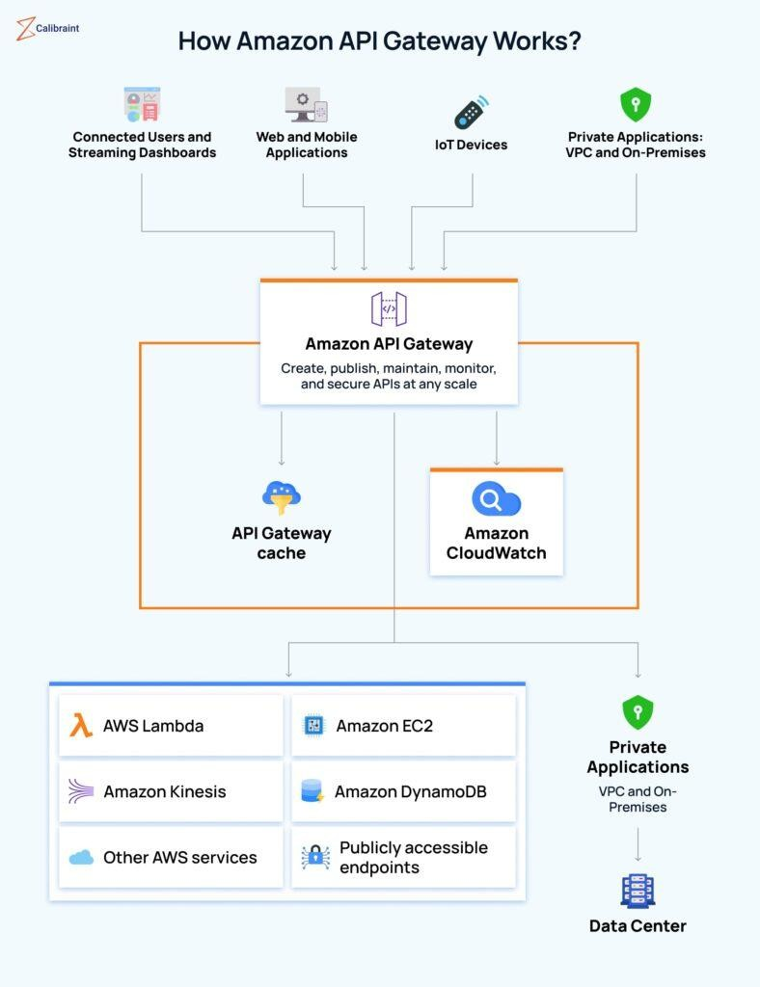

To create an API Gateway endpoint, follow these steps:

* Go to your AWS console and click on API Gateway under Networking & Content Delivery.
* Click on Create API and choose REST API.
* Enter a name for your API. (You can use any random name)
* Choose Regional as the endpoint type and click on Create API.
* Click on Actions and then go to Create Resource.
* Enter a name for your resource. You can use any name that you like, such as data.
* Check the Enable API Gateway CORS option. (This will allow your web page to make cross- origin requests to your API)
* Click on Create Resource.
* Click on the name of your resource and then click on Actions to Create Method.
* Choose POST as the HTTP method and click on the checkmark icon.
* Choose Lambda Function as the integration type and check the Use Lambda Proxy integration option (This will pass the request data directly to your Lambda function)
* Choose the same region as your Lambda function and enter the name of your Lambda function in the Lambda Function field (For example, serverless-web-app-demo)
* Click on Save and confirm the permission to add a trigger to your Lambda function.
* Click on Actions and then Deploy API.
* Choose New Stage as the deployment stage and enter a name for your stage (You can use any name that you like, such as prod)
* Click on Deploy.
* Copy the URL of your API from the top of the page (You can use this URL to invoke your Lambda function from your web page)

### Step 5: Modify the HTML page to send and receive data from the API Gateway

The last step to building a serverless web app on AWS is to modify the HTML page to send and receive data from the API Gateway. You will use JavaScript to make an AJAX request to your API Gateway endpoint and display the response on your web page.

To modify the HTML page, follow these steps:

* Open your code editor and open your index.html file.
* Locate the line that says *xhr.open* (“POST”, “https://your-api-gateway-url”, true)
* Replace the URL with that of your API Gateway endpoint that you copied in the previous section. (It will be something like https://abc123.execute-api.us-east- 1.amazonaws.com/prod/data)
* Save the file.
* Go to your AWS console and click on S3 under Storage.
* Click on the name of your bucket and then click on Upload.
* Click on Add files and select your index.html file from your computer.
* Click on Upload.

### Step 6: Test and deploy the serverless web app

After building a serverless web app on AWS, we can proceed with testing and deploying it. You can use your browser to access the web page to see how it works.

* Open your browser and paste the URL of your HTML page that you copied earlier. (This should bring up your webpage)
* Enter your name and email address in the input fields and click on Submit.
* Now you should see a message that says “Thank you for submitting your details!” and a console log that shows the response from your Lambda function.
* You can also open the console by pressing Ctrl+Shift+I on Windows or Cmd+Option+I on Mac and clicking on the Console tab.
* Go to your AWS console and click on DynamoDB under Database.
* Click on Tables and then click on the demo.
* Click on Items. (Now you should be able to see an item with your name and email address as the values)

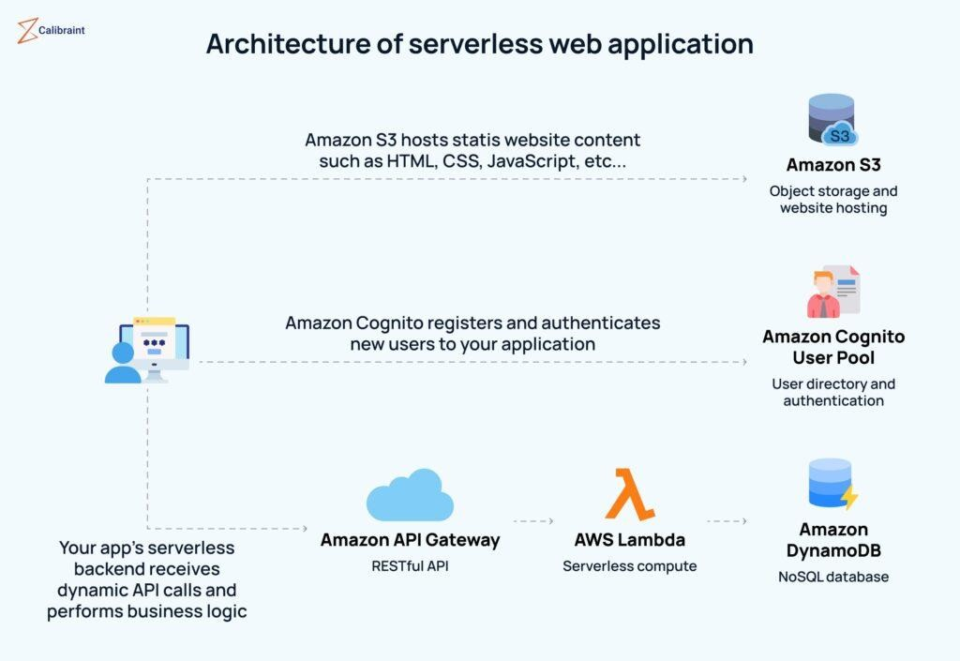

Now that you have tested the serverless web app and verified that it works as expected, you can proceed to deploy it. There is no additional step required to deploy the serverless web app. You can directly share this URL with anyone who wants to use your web app. In case if you want to use a custom domain name for your web app you will need to register a domain name with a domain registrar.

How to make changes to a serverless web application built with AWS lambda?

In case you change your mind and want to make any changes to it, here’s how you can do it.

* If you want to make any changes to your web page, such as changing the layout, style, or functionality, you can edit your index.html file in your code editor and upload it to S3 again.
* If you want to change your Lambda function, such as changing the logic, parameters, or output, you can edit your code in the AWS console or use the AWS CLI to update your function.
* If you want to make any changes to your API Gateway endpoint, such as changing the method, resource, or integration, you can edit your settings in the AWS console and deploy your API again.
* If you change your mind and want to delete it, go to your AWS console and click on S3 under Storage to delete your S3 bucket. Click on the name of your bucket and then click on Empty. Confirm that you want to delete all the objects in your bucket. Then click on Delete and confirm that you want to delete your bucket.
* To delete the Lambda function, click on Lambda under Compute in your console. Click on the name of your function, and then proceed to Actions and then Delete. (Click confirm in the prompt on your screen to proceed)

### Conclusion

Now that you can build a serverless web app on AWS on your own, you can scale it up easily. By using AWS Lambda, DynamoDB, and API Gateway you can build reliable, and cost-effective web applications without managing any servers.

**Result:** Thus, Serverless Web App using AWS has been developed successfull